START PAGE

Marie Skłodowska-Curie Actions

Research and Innovation Staff Exchange (RISE)
Call: H2020-MSCA-RISE-2019

PART B

“PROBES”

TABLE OF CONTENTS
2. EXCELLENCE………………………………………………………………………………………………………………………………...3
2.1 Quality and credibility of the research/innovation action; level of novelty and appropriate consideration of inter/multidisciplinary, intersectoral and gender aspects…………………………………………………..3
2.2 Quality and appropriateness of knowledge sharing among the participating organizations in light of the research and innovation objectives………………………………………………………………………………………………………14
2.3 Quality of the proposed interaction between the participating organizations……………………………….15
3. IMPACT……………………………………………………………………………………..................................................17
3.1 Enhancing the potential and future career prospects of the staff members.……………………………….…17
3.2 Developing new and lasting research collaborations, achieving transfer of knowledge between participating organizations and contribution to improving research and innovation potential at the European and global levels…………………………………………………………………………………………………………………………17
3.3 Quality of the proposed measures to exploit and disseminate the action results…………………………..18
3.4 Quality of the proposed measured to communicate the action activities to different target audiences……………………………………………………………………………………………………………………………………………………19
4. QUALITY AND EFFICIENCY OF THE IMPLEMENTATION………………………………………………………………..20
4.1 Coherence and effectiveness of the work plan, including appropriateness of the allocation of tasks and resources…………………………………………………………………………………………………………………………..……20
4.2 Appropriateness of the management structures and procedures, including quality management and risk management……………………………...............................................................................................................30
4.3 Appropriateness of the institutional environment…………………………………………………………………………31
4.4 Competences, experience and complementarity of the participating organizations and their commitment to the action………………………………………………………………………………………………………………………….32
5. REFERENCES………………………………………………………………………………………………………………………………33
6. CAPACITIES OF THE PARTICIPATING ORGANIZATIONS……………………………………………………………….35
7. ETHICAL ISSUES………………………………………………………………………………………………………………………….61
8. LETTERS OF COMMITMENT OF TC PARTNER ORGANIZATIONS ………………………………………………….62

START page count – MAX 30 pages
2. Excellence
2.1 Quality and credibility of the research/innovation action; level of novelty and appropriate consideration of inter/multidisciplinary, intersectoral and gender aspects
PROBES will promote and reinforce the international and intersectoral collaboration among European, American and Japanese research institutions and industries involved in some of the most important research projects in fundamental physics. In the last few years, PROBES researchers have made outstanding contributions to the design of cutting-edge physics experiments capable of opening new windows in the field of particle physics. They are now involved in the construction, commissioning and data analysis of these projects, and the next generation projects which require maximum exchange of skills and knowledge and substantial technological advancements with applications also outside particle physics and potential market opportunities for non-academic participants. Through the extended exposure to new research environments in world-class laboratories and universities in US and Japan, PROBES researchers and technical staff will have their career perspectives broadly widened.

2.1.1 Specific objectives and the relevance of the research and innovation project to the scope of the call and in relation to the “state of the art”.
Light Dark Matter. Many astrophysical observations as well as anomalies in processes involving electromagnetic currents (e.g. the muon anomalous magnetic moment) could be reconciled assuming the existence of a new kind of matter, not directly interacting with light, called Dark Matter (DM). While gravitational effects of DM are quite well established, despite the tremendous efforts being devoted to reveal the nature of DM in terms of new elementary particles, no clear results have been obtained so far. Many experimental efforts are dedicated to direct detection of galactic DM, as well as to study the indirect effects of its presence. Due to the lack of results by ‘traditional’ DM searches, in the last few years the experimental activity extended to search for hints of DM produced at accelerators. Technological advances allow nowadays running high intensity electron beams of moderate energy well suited for these studies. According to some theories beyond the Standard Model (SM), Light Dark Matter (LDM) (1-1000 MeV) can interact with SM matter via a new force, mediated by a heavy vector boson called A’ or ‘heavy photon’. Depending on the relative masses of the A’ and the DM particles, the A’ can decay to SM particles (‘visible’ decay) and/or to light DM states (‘invisible’ decay). At JLAB, an extensive experimental program is being pursued to search for signatures of both dark matter fermions and bosons. In the HPS experiment, the dark photon A’ is searched for looking at its visible decay (A’ to e⁺e⁻ pairs) as a narrow bump over a smooth QED-induced background, for either prompt or detached decay vertexes (Figure 1, Left). Results from engineering runs performed in past years demonstrated that the experiment is ready to produce physics quality data [1]. An intense R&D program is undergoing for the new Beam Dump eXperiment (BDX), approved with the highest scientific rate as part of a new JLAB facility for light dark matter search [2]. In this experiment a dark matter beam is expected to be produced in the interaction of the CEBAF high intensity primary electron beam with the dump at the end of its life. A detector placed downstream of the dump, shielded against the copiously produced SM particles, will be able to detect the DM-electron interaction by detecting the electromagnetic shower induced by the struck electron. Collecting data for about a year at the highest beam intensity available at JLAB the experiment should be able to improve by two orders of magnitude the sensitivity on DM with respect the existing results, at a level far enough to test some of the most motivated theoretical scenarios (Figure 1, right).

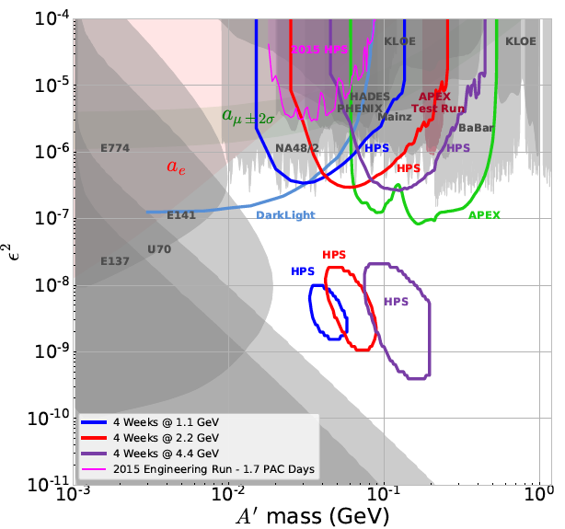 | 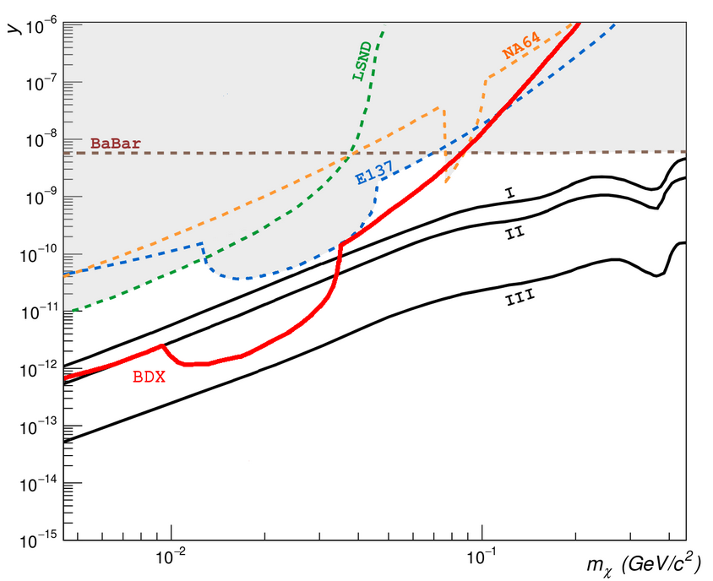
Figure 1: (Left) Expected reach of the HPS experiment, as a function of the coupling ε and mass of a dark photon decaying into ordinary matter (e+e- pair). | (Right) Expected reach of the BDX experiment in terms of coupling and mass of the light dark matter, extending towards the relic limit derived from cosmological observations.

Ultra-dense Matter Equation of State (EoS). With the advent of the multi-messenger era in cosmic observations, realistic perspectives exist to advance in the understanding of neutron stars structure and fate, and pin down the so far elusive Equation of State (EoS) of the matter in extreme conditions of pressure and density. Despite the 10¹⁹ scale difference, there is a common origin of the pressure in neutron rich matter, either fighting surface tension in heavy nuclei or gravity in neutron stars. Laboratory measurements, done at JLAB in controlled and reproducible conditions, can complement the constraints provided by gravitational wave interferometers. The PREX experiment (Pb Radius Experiment) is going to measure the difference between the neutron and the proton radius (neutron skin) of ²⁰⁸Pb, a neutron rich isotope, by polarized electron-nucleus scattering. There is a strong correlation between such an ion neutron radius R_{N} and critical parameters of the neutron star, e.g. pressure and radii, the probability that the massive star cools down quickly by neutrino radiation [3] and to the crust thickness, i.e. the density transition from the solid crust to the liquid interior [4]. PREX has already collected a first set of data [5]. An extended run of increased statistics is planned in the near future, to achieve constraints on the neutron star radius comparable with cosmic observations (Figure 2, Left). In ultra-dense neutron matter, whenever the chemical potential approaches the one of a hyperon in the same matter, the hyperon should become stable since it is a distinguishable particle, and creates its own Fermi sea, thereby lowering the kinetic energy of the system. The appearance of hyperons in the inner core of neutron stars, though energetically favoured, would imply a softening of the EoS to a level incompatible with the observed masses. This hyperon-puzzle might be solved by models that introduce repulsive three-body forces at high densities (Figure 2, Right). The inclusion of the three-body repulsive ΛNN forces at high densities cannot be inferred by the high resolution spectroscopy of light hypernuclei performed so far at JLAB using electrons as probe, while the spectroscopy of medium heavy hypernuclei already performed with hadronic probes did not have the necessary resolution. At JLAB, a hypernuclear spectroscopy program is aiming to determine the isospin dependence of the hyperon interaction, which should play a prominent role in the neutron dominated matter, comparing the Λ separation energies in medium heavy nuclei with different proton and neutron content.

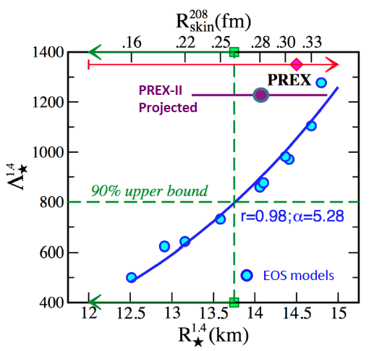 | 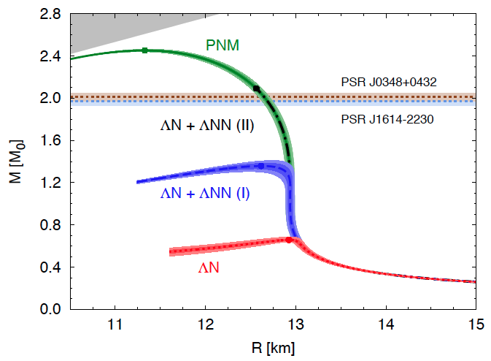
Figure 2: (Left) Relationship between tidal deformability parameter (Λ) and radius (R) of a neutron star as outlined by various EoS models (cyan). Limit to the radius derived from the gravitational wave GW170817 observation (green). Past and projected PREX constraints (red, magenta). | (Right) Simulated mass-radius relation of a neutron star for different hypothesis of the hyperon content. Close circles represent the predicted maximal mass. Horizontal bands at two solar masses indicate the observed masses of heavy neutron stars.

Dynamics of Confinement. The understanding of the fundamental structure of matter and the nature of quark confinement are among the most important challenges of contemporary physics: the dynamical generation of mass by the strong gluon-quark interaction within the nucleon, that accounts for 99% of standard matter, is beyond the origin of fermionic mass linked to the Higgs mechanism. While a true solution to QCD in the non-perturbative regime remains elusive, enormous progress has been made in the recent years with the introduction of new experimental and theoretical instruments. At the start of the new millennium, breakthrough observations involving spin control have driven the focus on the transverse degree of the partons and their correlations in a confined object, accessing for the first time intrinsic quantities generated at the scale of confinement. These include the azimuthal dependence of the final state products in polarized scattering processes involving hadrons [6][7] and the surprising Q² dependence of the nucleon form factors measured with the polarized transfer technique [8]. Theoretical advancements have provided a solid ground for an extended range of investigation with the development of Generalized Parton Distributions (GPDs) [9] allowing to describe both structure functions and form factors within a single unifying framework or Transverse Momentum Dependent Distributions (TMDs) [10] providing access to spin-orbit correlations of the strong-force and to the elusive tensor charge. At small Q², form factors are connected to the proton radius puzzle: a precise measurement of the proton radius by μ-p Lamb shift [11] results 7.9σ off the average measurements by e-p scattering and hydrogen spectroscopy. At large Q², GPDs allow a tomography (Figure 3, Left) of the nucleon and an estimate of the pressure experienced by the quarks in their confined space (the nucleon) [12]. The tensor charge is connected to searches of Beyond Standard Model phenomena as Electric Dipole Moment (EMD) of particles [13] and tensor interaction [14]. Perturbative QCD (pQCD) can predict how these quantities evolve with Q² providing predictive power [15]. Lattice QCD, which may ultimately provide arbitrarily accurate numerical solutions, has made remarkable progresses in the past decades [16] (Figure 3, Right). Several electron-nucleon scattering experiments are in preparation at JLAB to realize a comprehensive program of investigation with unprecedented precision, thanks to the world-record luminosity ranging from 10³⁴ up to 10³⁸ cm⁻²s⁻¹, at least three orders of magnitude greater than the previous generation of experiments done in EU.

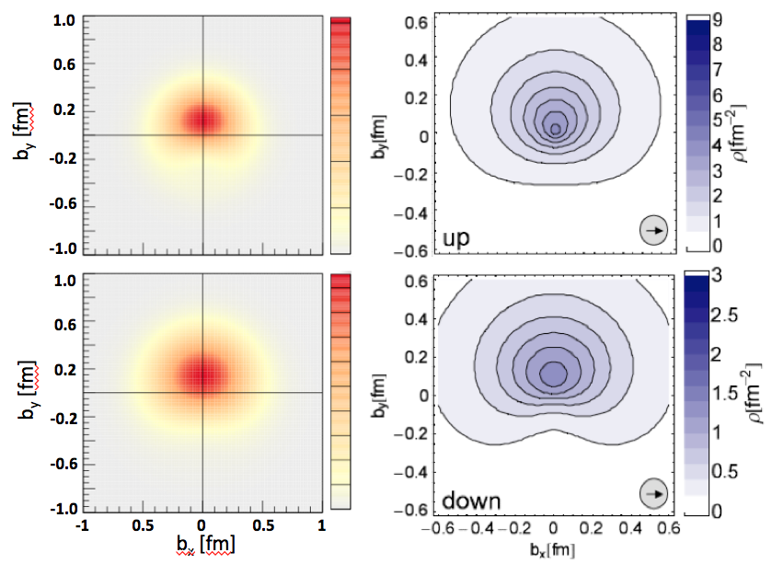 | 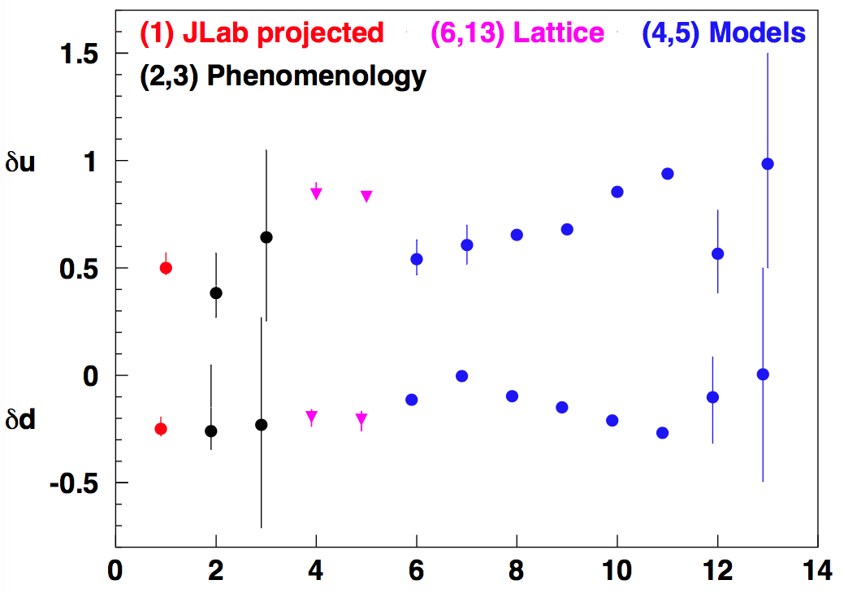
Figure 3: (Left) Imaging of polarization dependent u and d quark distribution inside the nucleon, as derived from hard-exclusive DIS reactions at x=0.3 (left column) in comparison with lattice calculations of the lowest moment of the quark density (right column). | (Right) Flavor separation of the proton tensor charge as calculated in lattice (magenta), models (blue), phenomenology from existing measurements (red) and projections for future measurements at JLAB (black).

Lepton Flavour Violation. The concept of flavour, i.e. the existence of three replicas of each family of elementary fermions with the same quantum numbers but different masses is a cornerstone in elementary particles physics, and it is realized in the SM by introducing three copies of the same gauge representations of the fermion fields. Experimental observations of neutrino oscillations have established a picture consistent with the mixing of three neutrino flavours with mass eigenstates having relatively small mass-splittings, i.e. Δm² ~ 2.6x10⁻³ eV² (atmospheric oscillations) and 7.4x10⁻⁵ eV² (solar oscillations) [17]. However, in recent years, several experimental anomalies have been reported that, if confirmed, could be pointing to the presence of additional neutrino states with larger masses participating in the mixing and not coupling to fermions: so-called “sterile” neutrinos [18]. Lepton mixings and massive neutrinos offer a true gateway to many new experimental signals or deviations from SM predictions in the lepton sector. Among others, these include also Charged Lepton Flavour Violation (CLFV). The most minimal SM extension accommodating neutrino oscillation introduces right-handed neutrinos while preserving the total lepton number and assumes the neutrinos are Dirac particles. In such a framework, individual lepton numbers are violated and CLFV transitions such as μ⁺→ e⁺γ occur through interactions of W bosons with massive neutrinos. However, due to the tiny masses of the light neutrinos, the associated rate is extremely small i.e. O(10⁻⁵⁵) about forty orders of magnitude smaller than the sensitivity of present day and future experiments [19]. When introducing new particles beyond the SM, branching fractions are enhanced and CLFV processes emerge as one of the distinctive features of these theories and make the search for CLFV very attractive. This means that an experimental observation of CLFV would be an unambiguous signature of new dynamics related to a non-trivial extension of the lepton sector of the SM and the impact on establishing new models would be huge.
Neutrino oscillations. The experimental observation of three-neutrino flavour oscillations [20] presently represents the main evidence for new phenomenology beyond the SM. Subsequent measurements of neutrino oscillation parameters, mixing angles and mass splitting [21], have become increasingly precise and are now beginning to probe CP violation in the lepton sector [22] and the mass ordering of neutrinos [23]. Understanding the origin of neutrino masses and explaining why they are so small relatively to the other elementary fermions is one of the priorities of particle physics and since an explanation is lacking within the SM, a deeper understanding of their properties could help elucidate the physics beyond the SM. Such new physics is hinted at by several experimental “anomalies” where several observations are consistent with an additional oscillation frequency. This includes measurements at accelerators [24], low energy anti-neutrino experiments at nuclear reactors and of Mega-Curie radioactive sources in the Gallium experiments designed to detect solar neutrinos [25]. The Liquid Scintillator Neutrino Detector (LSND) Collaboration reported a 3.8 excess of 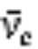 events from  pion and muon decays. This is consistent with oscillations at a characteristic mass splitting of m² > 0.1 eV², and inconsistent with the well-established atmospheric and solar mass splitting. The accelerator-based pion decay-in-flight MiniBooNE experiment has probed this high-m² parameter space with both neutrinos and anti-neutrinos. MiniBooNE reported a 4.7 excess [26] of events with a combination of their    and  searches. The results are dominated by a “low energy excess” of electron-flavour-like events at energies 200 - 475 MeV. The LSND and MiniBooNE results hint at the existence of at least one new neutrino mass eigenstate, which, based on LEP measurements of the Z boson width, would have to be “sterile” with regard to its SM interactions. Alongside these observed anomalies, KARMEN, NOMAD, ICARUS and OPERA [27] did not observe electron flavour appearance from a muon-flavour source at short and long-baselines, and have thus restricted the parameter space for sterile neutrinos. No anomalies have been observed in muon neutrino disappearance experiments [28], even though it is expected in models involving one or more light sterile neutrinos. An experimental clarification of the observed anomalies is therefore mandatory, and if confirmed an interpretation of them in the context of underlying physics models [29]. While reactor and source experiments will likely be able to provide a sensitive test of electron-flavour disappearance in the near future, definitive probes or electron-flavour appearance from a muon flavour source and muon-flavour disappearance are likely only possible using neutrinos from a particle accelerator. The short-baseline anomalies, which may be consistent with the existence of an eV-scale sterile neutrino, may be resolved by neutrino experiments observing oscillations at short baselines, such as the Short Baseline Neutrino (SBN) program in the high intensity Booster Neutrino Beam (BNB) at FNAL [30], along with measurements from other experiments [31]. For the mentioned experiments, the signature is the appearance of from an initial almost-pure beam identified from charged current interactions (Figure 4).
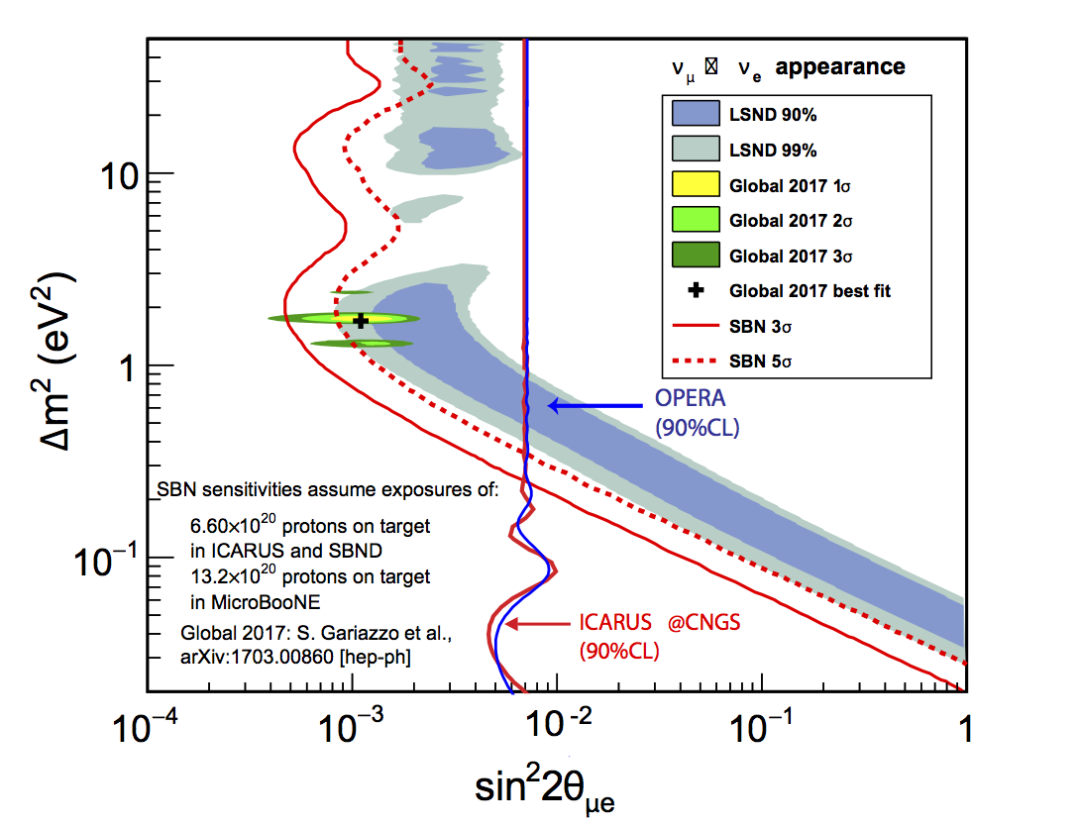 | 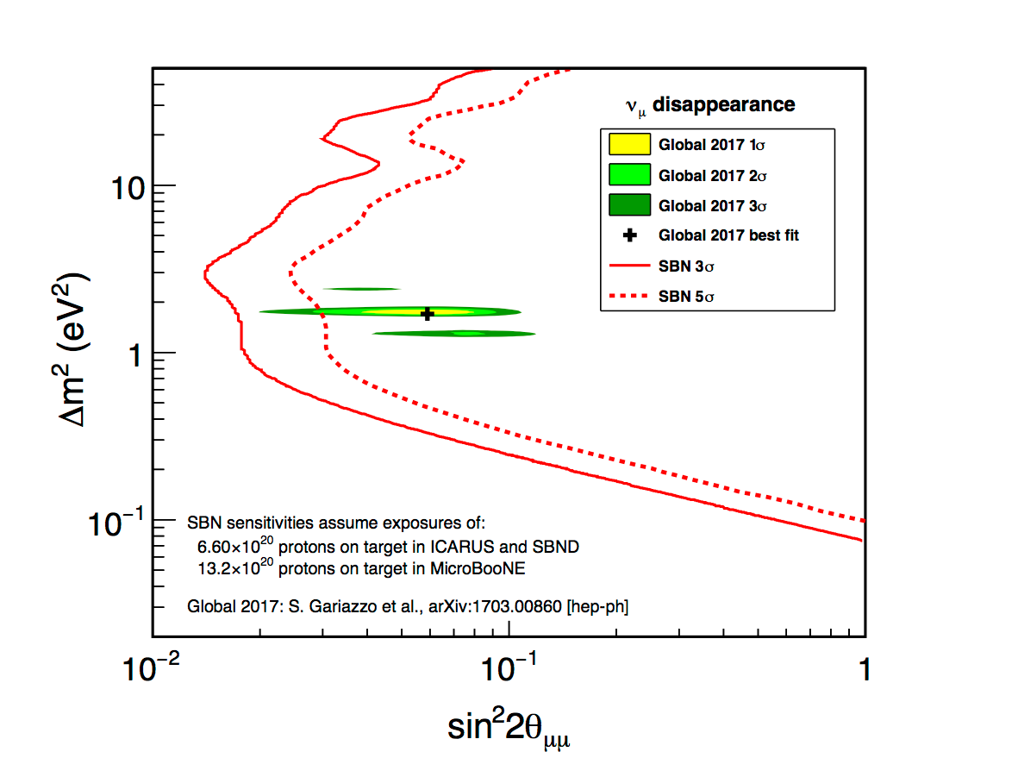
Figure 4: The expected sensitivities to 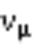→appearance (left) and 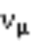disappearance (right), compared with the LSND allowed region and current global best fit [2]. The 90% CL limit obtained for  appearance in a 2ν oscillation analysis by ICARUS and OPERA at CNGS are also shown.
Charged Lepton Flavour Violation. There is still no evidence for Lepton Flavour Violation in processes involving charged leptons (CLFV), although the search for such a violation has been pursued over many years in a host of channels both at dedicated and general-purpose experiments. Searches for CLFV with muon beams can be performed with the ⁺ e⁺ decay, ⁺ e⁺e⁻e⁺ decay and ⁻ e⁻ conversion in the field of a nucleus [32]. MEG [33] and its upgrade MEG II at PSI in Switzerland search for the ⁺ e⁺ decay. MEG recorded 7.5x10¹⁴ ⁺ from 2008 to 2013 and set the upper limit of 4.2x10⁻¹³ at the 90% confidence level on the branching fraction. This is the most stringent limit on a CLFV decay to date (Figure 5, Left): the rightmost blue squares are the limits set with increasing statistics. MEG reached its final sensitivity and MEG II is now being commissioned. The goal is a sensitivity of 5x10⁻¹⁴ at the 90% confidence level. The Mu3e experiment [34] at PSI aims to reach a sensitivity of 10⁻¹⁶ on the ⁺ e⁺e⁻e⁺ decay. In this case, the large step in technology with respect to previous experiments will allow reaching uncharted territory in less than a week of stable data taking. The search for the CLFV coherent neutrino-less muon conversion to an electron in the field of a nucleus complements and extends the current MEG-II and Mu3e sensitivity to new sources of CLFV through the sensitivity to both dipole and contact interactions (Figure 5, Right). The current best limit of 7x10⁻¹³ is due to the Sindrum-II experiment at PSI [36] and will be improved by four orders of magnited by mid 2020s by COMET [36] at J-PARC and Mu2e at FNAL. The Mu2e setup allows for the concurrent search of muon-to-positron transition: ⁻ (Z,A)  e⁺ (Z-2,A).
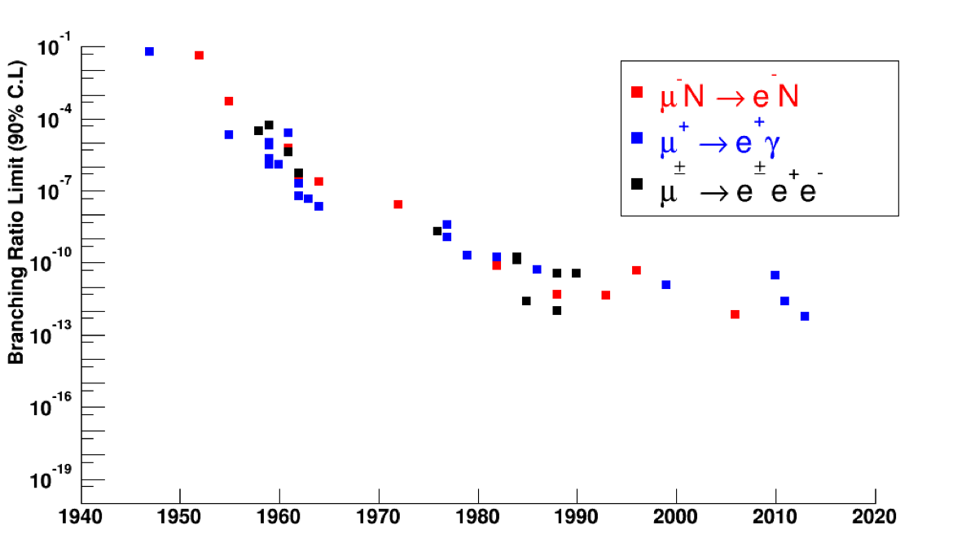 | 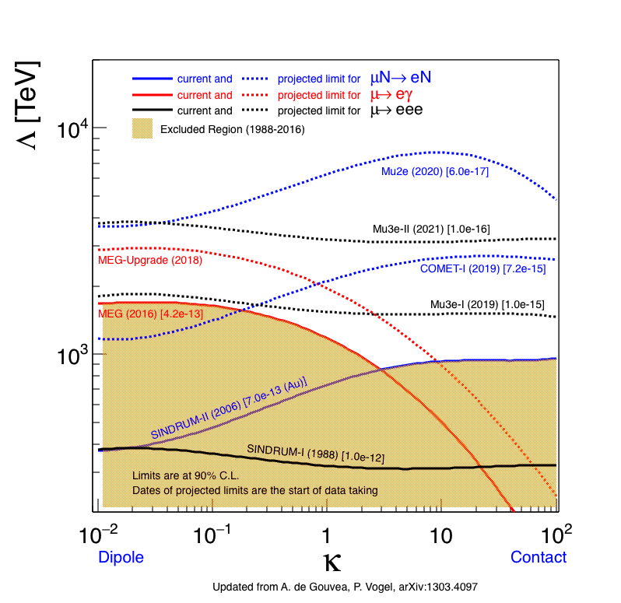
Figure 5: (Left) Limit on the branching fraction of flavour violating muon decays versus time. The three main clusters correspond to the use of cosmic ray muons (until the ‘50s), stopped pion beams (until the ‘70s) and stopped muon beams, The best limit is from the μ⁺→ e⁺γ decay set by the MEG experiment. | (Right) Sensitivity of MEG, Mu3e, Mu2e and COMET to the scale of new physics Λ as a function of the parameter κ: Mu2e has a mass scale discovery up to 10⁴ TeV, which is significantly above the direct reach at the LHC and roughly equal to that of the MEG II in loop-dominated (low κ) physics.
This is a CLFV and lepton-number violating (LNV) process and is guaranteed to occur if neutrinos are Majorana fermions, not unlike searches for neutrinoless double-beta decay. The best current limits are from the Sindrum-II experiment [37]: 1.7x10⁻¹² at the 90% confidence level for the ground state transition and 3.6x10⁻¹¹ at the 90% confidence level for a giant dipole resonance excitation with both a mean energy and a width of 20 MeV. The expected rate for muon-to-positron transition is very dependent on the mechanism behind neutrino masses, and any observation of a conversion implies that neutrinos are Majorana fermions. Mu2e is expected to provide, absent a discovery, bounds that are several orders of magnitude more stringent than current limits. CLFV phenomena probe new physics at a mass scale significantly beyond LHC direct searches. They may provide the only way of probing in the near future the new physics mechanisms that neutrino oscillations showed to be present in nature. Furthermore, models predicting new physics at the mass scale accessible at LHC, also predict CLFV processes at rates within the reach of the incoming CLFV searches that will provide fundamental information also in the event of a discovery at the LHC.

2.1.2 Methodological approach: detail the research and innovation activities proposed and their originality.
Light Dark Matter. The HPS experiment (Figure 6, Left) searches for the dark photon with mass in the range 0.01 to 0.5 GeV decaying to e⁺e⁻ pairs (visible decay), covering a virgin interval of values of the coupling to the electromagnetic current. The A’ is expected to be produced by the electron bremsstrahlung on a heavy target, and identified as a narrow e⁺e⁻ resonance (bump) over a smooth QED-induced background, dominated by the Bethe-Heitler pair production on nuclei. The weak coupling to SM particles (e.g. electrons) may explain why it was not yet been discovered. HPS has an enhanced sensitivity with respect to similar experiments because it adds, to the bump-hunting technique, the capability of identifying the A’ produced in a detached vertex. The experiment detects forward going electron-positron pairs produced on a thin W target using a silicon tracker situated in a dipole magnet and a PbWO highly segmented calorimeter. To achieve the required sensitivity the silicon tracker is positioned in vacuum only few millimeters away from the incident electron beam. The lead tungstate crystal calorimeter provides a fast trigger and sub-ns timing of the detected event.

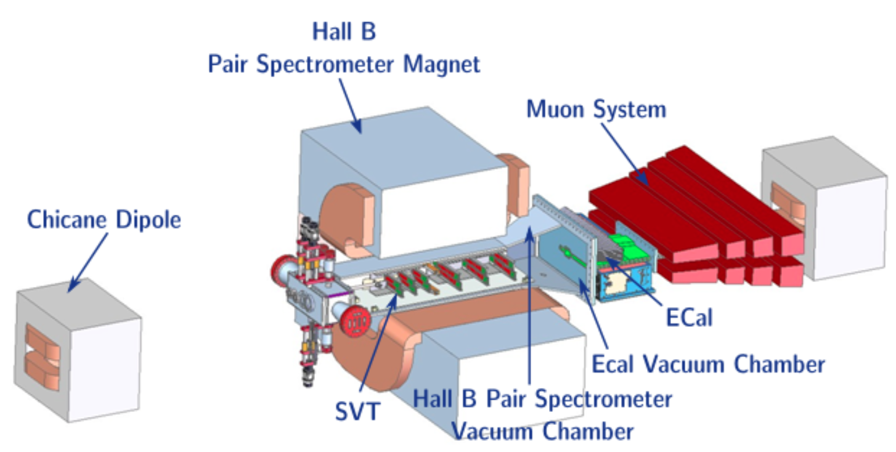 | 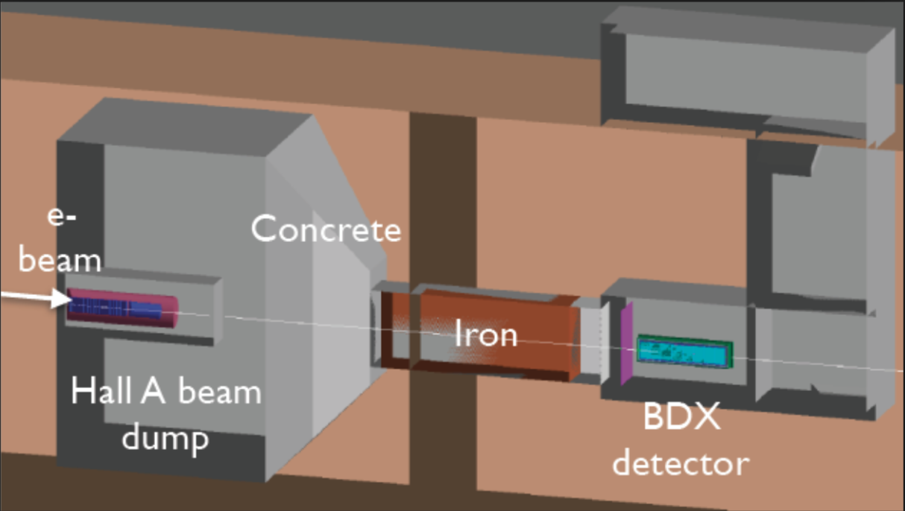
Figure 6: (Left) The HPS experiment layout. | (Right) The BDX experimental area.

The BDX experiment (Figure 6, Right) aims to improve by two orders of magnitude the present sensitivity on dark matter in a wide mass range by exploiting the highest beam intensity achievable at JLAB (up to ~100 μA). Dark matter produced by the interaction of the CEBAF primary electrons with the Hall-A beam dump, would propagate through a concrete-iron shield, and interact with a massive active detector located 20m downstream of the dump. In a year, the experiment will accumulate up to 10²² electrons-on-target. The active volume of the detector (~cubic meter) will be made by ~1000 CsI(Tl) crystals formerly used in the BaBar electromagnetic calorimeter, surrounded by two layers of plastic-scintillator active vetoes and a passive lead vault. The distinct signature of a DM interaction will be an electromagnetic shower of few hundreds of MeV, together with a reduced activity in the surrounding active veto counters. The experiment would be sensitive to elastic DM-electron and to inelastic DM scattering at the level of 10 counts per year, reaching the limit of the neutrino irreducible background. Pilot runs are being planned with small-scale demonstrators to validate the method and achieve first physics outcomes.
New Matter EOS. PREX-II (Figure 7, Left) goal is a 1% precision measurement of R_{N}, the RMS radius of neutrons, in a ²⁰⁸Pb nucleus. In addition to being a fundamental test of nuclear theory, a precise measurement of R_{N} pins down the density dependence of the symmetry energy of neutron rich nuclear matter that has impacts on neutron star structure, heavy ion collisions, and atomic parity violation experiments. PREX-II measures the parity-violating electroweak asymmetry in the elastic scattering of polarized electrons from ²⁰⁸Pb at the energy of 1.0 GeV. Since the Z⁰ boson couples mainly to neutrons, this asymmetry provides a clean measurement of R_{N.} PREX-I ran in 2010 and demonstrated successful control of systematic errors and overcame many technical challenges. Despite the limited statistics, yet already established the existence of the neutron skin at the 95% confidence level. One of the challenges is the development of a Pb target that could operate at high beam currents, exceeding 70 μA, without melting. Beam rastering synched with the helicity flip rate of the beam and diamond backing with high thermal conductivity will be used to achieve the required target lifetime. At JLAB, a hypernuclear spectroscopy is aiming to determine the isospin dependence of the ΛN interaction, which should play a prominent role in the neutron dominated matter. Experiment E12-15-008 will compare the binding energy spectra of medium heavy hypernuclei ⁴⁰ΛK and ⁴⁸ΛK with different neutron content. An electron beam of 4.5 GeV energy will be incident on a target to produce Λ hypernuclei through the (e,e'K⁺) reaction. The measurement of the scattered electron and K⁺ momenta will provide superior resolution after calibration wit the control reactions p(e, e’K⁺)Λ and p(e,e’,K⁺)Σ. A dedicated system of septa and particle identification is required to work at small scattering angles, where the hypernucleus formation cross-section is not negligible.

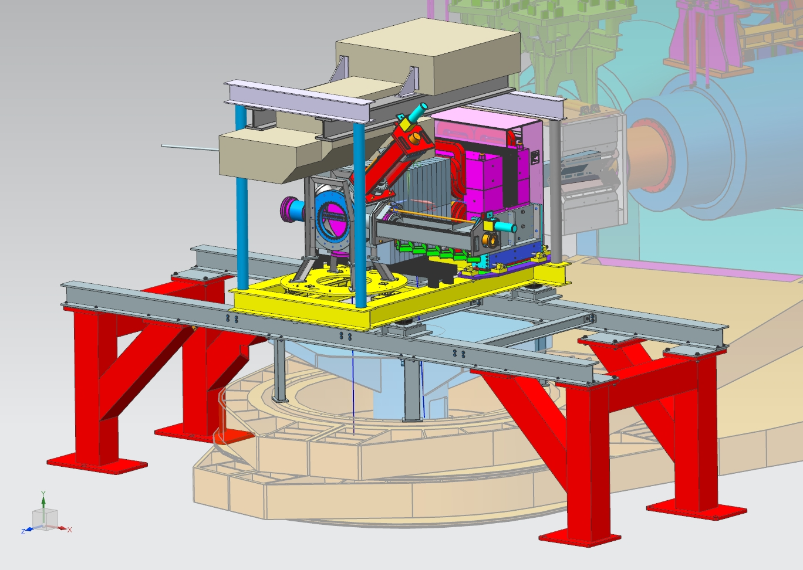 | 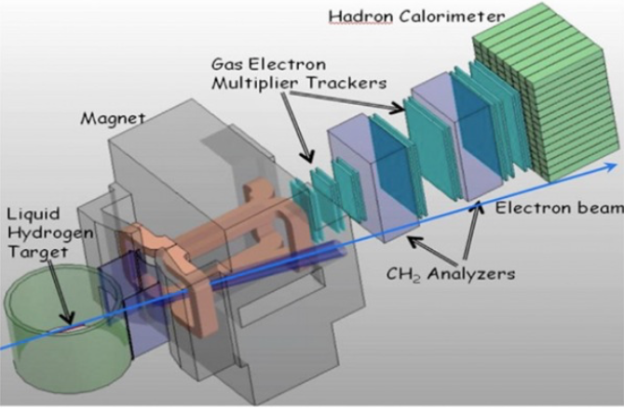 | 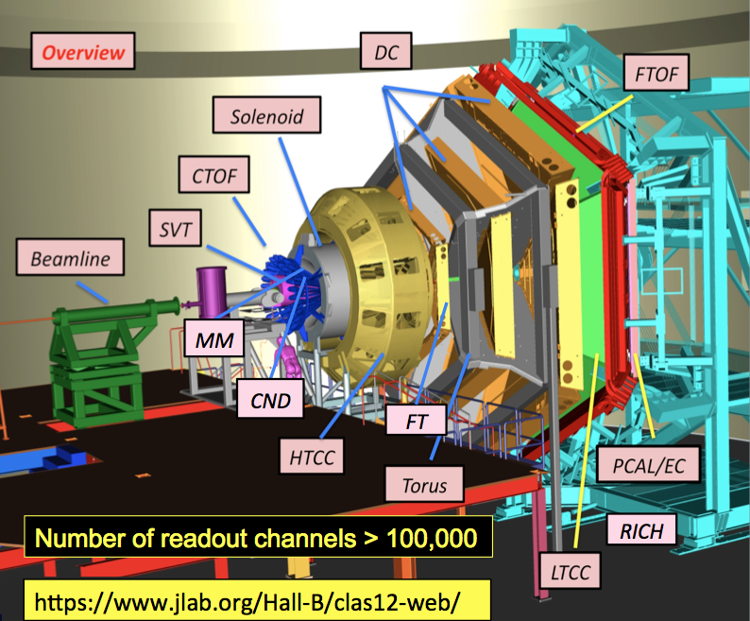
Figure 7: (Left) PREX-II target area. | (Center) The SBS spectrometer in JLAB Hall-A for scattering experiments at the intensity frontier (up to 10³⁹ cm⁻²s⁻¹). | (Right) The large-acceptance CLAS12 spectrometer in JLAB Hall-B covering the target and the forward scattering regions.

Dynamics of Confinement. Two complementary approaches are being pursued based on a challenging instrumentation upgrade. The CEBAF Large Acceptance Spectrometer at 12 GeV (CLAS12) in Hall-B will explore an extended portion of the phase space. The two-arm spectrometers in Hall-A will perform precision measurements at large Q². The JLAB accelerator is capable of delivering beams of up to 85 μA, which corresponds in some experiments to the challenging luminosities of 10³⁹ s⁻¹cm⁻². The nucleon (proton or neutron) has an internal, spatially extended electro magnetic structure that can be described by the electric G^{E} and magnetic G^{M} Form Factors (FF) normalized to the nucleon charge and anomalous magnetic moment. In fact, since the pioneering measurement at SLAC [38] in the ’50 experiments based on the Rosenbluth separation have supported the dipole description and a fairly constant ratio R_{p}(Q²) ≡ μp G^{E}_{p} /G^{M}_{p} ≈ 1. This apparent consolidated situation has been mined by a new class of measurements of R_{p} performed at JLAB in the past decade [39] by means of the polarization transfer method at relatively high Q² (up to 8 GeV²) where quark orbital angular momentum and gluon polarization effects would manifest [40]. Starting in 2020, the Super-Bigbite Spectrometer (SBS) [41] in Hall-A will be used in different configurations to measure various nucleon form factors in currently unexplored regions of large Q² (Figure 7, Center). Together with the experiment E-12-09-016 on the neutron G^{E}_{n} (by double polarization) and E-12-09-019 on G^{M}_{n} (by deuteron cross sections ratio), the experiment E-12-07-109 on the proton form factor ratio at Q² around 10 GeV² is likely the most demanding. The Figure of Merit (FOM), proportional to Q⁻¹⁶ mainly due to the elastic cross-section dependence, requires a detector package capable of operating at the largest possible luminosity (up to 10³⁹ cm⁻²s⁻¹) over an intermediate solid angle of 70 msr. To this goal, large Gaseous Electron Multiplier (GEM) chambers are used as trackers for both the primary charged hadrons [42] and the scattered secondary in the polarimeter [43] with a sub-100 μm spatial resolution. Efforts are underway to develop a sparse readout based on pulse shape analysis and real-time information from other detectors (hadron calorimeter) to suppress at the firmware level the noise and maximize the sustainable luminosity of the experiment. Several polarized deep-inelastic scattering experiments at JLAB will measure with unprecedented precision a variety of observables sensitive to the dynamics of quark-gluon interactions within the most common confined object (the nucleon). The experiments aim to connect kinematics and flavors of the struck quark to the chose target and observed particles properties. To correlate transverse momentum (TMDs) or transverse position (GPDs) information to the spin, polarized beam and targets are required. Among the most demanding experiments, are the ones using a transversely polarized target to access the elusive transversity distribution and its moment, the tensor charge. Experiment E12-09-018 plans to use SBS in conjunction with a transversely polarized gaseous ³He target, able to sustain 65% polarization with a 15 μA beam (a world record). Despite its large acceptance, covering both the hard interaction products and the target fragments, CLAS12 is designed to work at a luminosity of 10³⁵ cm⁻²s⁻¹, and get in just 1 day the same data collected in years of data-taking by the precursor DIS experiments (Figure 7, Right). Experiment C12-11-111 plans to use CLAS12 in conjunction with a transversely polarized target, possibly made of a frozen-spin HD-ice, whose almost pure target substrate material should suppress unwanted nuclear effects, to measure transversity and quark spin-orbit effects on proton and neutron. While using an unpolarized deuteron target, experiment E12-11-003 plans to tag scatterings off the neutron using the central CLAS12 detector completed by a neutron detector, to gather information on the quark orbital motion. At JLAB experiments will cover the crucial valence region, at Bjorken x greater than 0.1, where no data are available despite the largest spin-momentum correlation effects are expected. The anticipated statistical precision will be decisive in allowing multi-dimensional analyses, a necessary requirement to isolate the leading effects and resolve specific correlations. To achieve flavor sensitivity, an innovative ring-imaging Cherenkov detector is under construction for CLAS12. It adopts a hybrid-design mixing the imaging of direct and reflected light to reduce the active area.
Lepton Flavour Violation experiments.
Neutrino oscillations. The FNAL SBN program is based on three almost identical liquid argon TPC detectors (MicroBooNE, ICARUS, SBND) located along the BNB and will deliver a compelling physics opportunity that can resolve the experimental anomalies and perform the most sensitive search to date for sterile neutrinos at the eV mass scale through both appearance and disappearance oscillation searches. The oscillation signal will be searched for by directly comparing the neutrino event spectra measured at different distances with respect to the source. In the absence of “anomalies” the 3-detector signals should be a close copy of each other for all experimental signatures, owing to the almost complete cancellation of common systematic uncertainties. The search for CP violation and sterile neutrinos requires high precision measurements of genuine appearance above the much larges beam component. The main background for charged current events in neutrino experiments, especially in Cherenkov Imaging Detectors, is from π⁰ mesons in neutral current interactions. The π⁰ mesons decay into pairs of energetic γs which convert primarily through pair production and can mimic electrons in most neutrino detector technologies, especially if two electromagnetic showers overlap or one γ escapes the detector. The liquid argon time projection chamber (LAr-TPC) technology provides excellent neutrino event measurement with a spatial resolution of the order of a mm, along with a good measurement of the deposited energy and e/γ separation [44]. In the LAr-TPC ionization electrons are drifted by a uniform electric field to three successive planes of sense wires with different orientation where they are detected. The drift coordinate is determined from the drift time. The LAr-TPC allows precise full-3D event reconstruction. The accurate measurement of the energy loss dE/dx versus range and the sampling of the ionization signal of each charged particle at the mm level, compared to the X₀ = 14 cm in liquid argon radiation length, allows particle identification by measuring the γ conversion point with high accuracy. The local measurement of dE/dx permits to recognize electron event candidates by the signature of their initial minimum ionizing particle signal evolving into an electromagnetic shower generated in the γ conversions. This sophisticated e/γ discrimination, with the reconstruction of invariant mass of any photon pair allows the rejection of the π⁰ background from neutral current interaction at an unprecedented level.
The FNAL SBN program exploits three LAr-TPC detectors built and operated by collaborations from Europe and US with leading contributions from PROBES researchers. ICARUS and SBND will be operated together with MicroBooNE that has been taking data since 2015. The three LAr-TPCs are at a shallow depth and exposed to the 0.2-2.0 GeV BNB neutrino beam at distances of 110 m (SBND), 470 m (MicroBooNE) and 600 m (ICARUS) from the neutrino source, respectively. To mitigate the cosmic muon background the LAr-TPCs have been equipped with segmented Cosmic-Ray Tagging (CRT) systems comprising plastic scintillation slabs read out by silicon PMTs. This is already operational for MicroBooNE and similar systems are being constructed for SBND and ICARUS. These systems will unambiguously identify cosmic-rays entering the detectors and minimize the induced background. The SBN program is the first step towards the DUNE US flagship project based on the same LAr technology for which the CERN open science model to build a large international Collaboration has been adopted. CERN participation in SBN and DUNE represents the first CERN involvement in an international effort not based on its particle accelerators. CERN has also constructed and operated since 2018 the single-phase DUNE Far Detector prototype ProtoDUNE as part of the effort towards the construction of the first DUNE 10-kt fiducial mass far detector module.
Charged Lepton Flavour Violation. MEG-II [45] will achieve the highest possible sensitivity by making maximum use of the available muon intensity at PSI with the basic principles of the MEG experiment and improved detectors. In MEG-II positive surface muons are stopped at the rate 7×10⁷ s⁻¹, more than twice that of MEG, in a thin slanted polyethylene target. The target is located at the centre of a detector composed by a Liquid Xenon (LXe) calorimeter and magnetic spectrometer built by PROBES researchers (Figure 8, Left). The spectrometer uses the gradient magnetic field to sweep away the low-momentum positrons. Positron tracks are measured with a newly designed single-volume cylindrical drift chamber. The positron time is measured with improved accuracy by a new pixelated timing counter based on scintillator tiles read out by SiPMs. The new spectrometer increases the signal acceptance by a 2x factor due to the reduction of inactive materials. The photon energy, interaction point position and time are measured with an upgraded LXe photon detector. The new Radiative Decay Counter identifies low-momentum positrons associated to high-energy radiative muon decay photons. The signature of the μ⁺→ e⁺γ decay at rest is a mono-energetic, back-to-back, time coincident γ and e⁺. The main background is due to accidental coincidences of high-energy positrons produced in the Michel decay μ⁺→ e⁺  and high-energy gamma from the annihilation of a positron, or bremsstrahlung, or the radiative μ⁺→ e⁺  decay. MEG-II allows also for dark matter searches, such as Majoron production via the two-body decay μ⁺→ e⁺J. For a massless Majoron the event signature is a monochromatic line at the endpoint of the energy Michel energy spectrum, with the Michel positrons as the main background source.

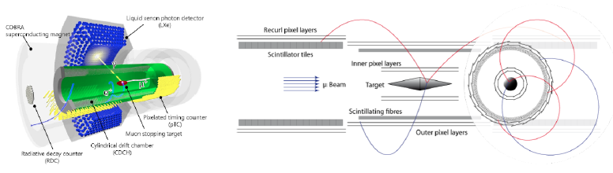
Figure 8: (Left) The MEG-II apparatus comprises a Liquid Xenon calorimeter and a spectrometer made of a cylindrical highly transparent single volume drift chamber combined with plastic scintillators inside a gradient magnetic field. (Right) The Mu3e apparatus comprises two double layers of silicon pixel detectors, complemented by a scintillating fibre tracker. At the sides two layers of pixel sensors surround a timing hodoscope made of scintillator tiles.

Mu3e at PSI will improve by four orders of magnitude the current limit of 10⁻¹² on the branching fraction of the μ⁺→ e⁺e⁻e⁺ decay and achieve a sensitivity of 10⁻¹⁶. Positive muons are stopped in a thin Mylar target surrounded by a cylindrical detector developed by PROBES researchers and located inside a 1 T magnetic field (Figure 8, Right). The silicon pixel tracking detectors allow for precise measurement of the vertex position and momenta of the charged particles, with a vertex resolution better than 200 micron and a momentum resolution of the order of 500 keV/c. Two timing systems, the first one based on a fiber tracker, and a second one based on scintillating plastic tiles, help to reject the combinatorial background. The signal signature is two positrons and one electron in a time coincidence, with total energy equal to the muon mass, and null vector sum of all the particle momenta. The main sources of background are due to the accidental coincidence of three charged tracks mimicking the signal, and radiative decays with internal conversion and a minimum energy carried away by the neutrinos. The internal conversion background is suppressed thanks to the excellent momentum resolution. The combinatorial background is suppressed using the excellent vertex and timing resolution. The subdetectors feature detection efficiencies approaching 100%. Mu3e is also the ideal apparatus to search for dark photon production via μ⁺→ e⁺ A’ with A’ → e⁺e⁻. The signature of the dark photon is a resonance in the invariant mass of the e⁺e⁻ pair of the radiative Michel decay with internal conversion μ⁺→ e⁺ γ. Displaced e⁺e⁻ vertices can also be used to search for long-lived dark photons.

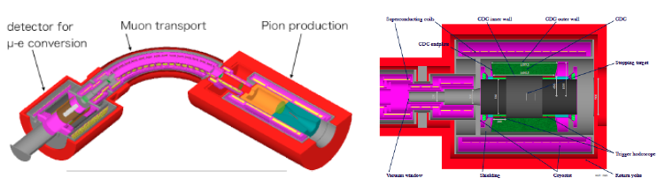
Figure 9: (Left) The layout of COMET Phase-I experiment. The pion capture solenoid system with proton target in the center (right part), the muon transport solenoid system (middle part), and the CyDET detector system with muon stopping target in the center (left part) are shown. (Right) The CyDET layout.

The COherent Muon to Electron Transition (COMET) experiment at J-PARC will search for the μ⁻ N(A,Z)→ e⁻ N(A,Z) conversion and has chosen a staged approach: COMET Phase-I is currently under construction (Figure 9, Left) and is aiming at a factor 100 improvement over the current limit set by Sindrum-II, COMET Phase-II will bring a factor of 100 further improvement on the sensitivity. COMET will exploit the 8 GeV pulsed proton beam which is slow-extracted from the J-PARC Main Ring using a newly built proton beamline. Muons are charge- and momentum selected using solenoid magnets to enhance their capture in the Aluminium target. The event signature is a 105 MeV mono-energetic electron emitted from the target. Aluminium has been chosen for the target for the lifetime of the muonic Al-atom and the expected rates for CLFV processes. An X-ray Monitor observes the X-rays emitted by these muonic atoms to determine their rate of production. The signal electrons are either measured directly by a cylindrical detector surrounding the Aluminium target and placed within a 1 T magnetic field (COMET Phase-I) or transported through an electron spectrometer composed of superconducting solenoids (COMET Phase-II) prior to their detection. The additional solenoid system filters lower and higher momentum particles except electron momentum from muon conversion and greatly reduces the beam backgrounds. The main detector measuring the electron signal for Phase-I (Figure 9, Right) is a cylindrical drift chamber together with a set of trigger hodoscope counters (CyDet). The drift chamber has full track-coverage for a 105 MeV electron from muon conversion and rejection for electrons with energy below 60 MeV. The chamber has been designed to be as low mass as possible to achieve a momentum resolution is 200 keV/c for low momentum measurements. The spatial resolution better than 200 μm has been measured during cosmic ray tests. COMET will achieve maximal suppression of two of the main backgrounds affecting the measurement, i.e. beam-induced and cosmic-ray induced backgrounds, and tight control of the background induced by the muons stopped in the target. Beam related backgrounds are suppressed by the use of a pulsed proton beam with very low proton leakage between pulses and shorter beam duration with respect to the lifetime of the muonic Al-atom and a repetition longer than this lifetime. The cosmic-ray induced background is eliminated using passive shielding and covering the apparatus with Cosmic Ray Veto detectors, i.e. scintillators and Glass Resistive Plate Chambers, built by PROBES researchers. After the Phase-I experiment, a special beam measurement program is planned for a direct estimation of the beam-related background. This estimate will be applicable to the tuning of simulation and sensitivity estimate of Phase-II experiment, a necessary step when taking into account that COMET will use the most intense pulsed muon beam in the world [46].
The “muon-to-electron conversion” (Mu2e) experiment at FNAL will improve the sensitivity to the neutrinoless μ⁻ N(A,Z)→ e⁻ N(A,Z) conversion by four orders of magnitude with respect to Sindrum-II. This sensitivity can be achieved with the pulsed-muon beam (10¹¹μ/s) provided by the FNAL Muon Campus. A number of twisted solenoids transport the muons from the production target to the stopping target and remove backgrounds 1011) [47]. Only negative muons with a momentum below 100 MeV reach the Aluminium stopping target where 39% of the stopped muons decay in orbit (DIO), while 61% are captured by the aluminium nuclei. As in COMET, the CLFV signature is a single mono-energetic conversion electron (CE) with a momentum of 105 MeV. PROBES researchers are building the high-precision apparatus made of a straw tube tracker and an electromagnetic CsI crystal calorimeter to separate CE and DIO events and an X-ray HPGe detector called “stopping target Monitor” (STM) to determine the muon flux. Electrons with a momentum below 52 MeV escape through the un-instrumented region. The tracker is fully efficient above 90 MeV and provides an electron momentum resolution of 200 keV/c. A huge cosmic-ray veto surrounds the detector to veto external muons and reduce the fake events to less than 0.1 in the full data-taking period. The Mu2e trigger consists of a set of software-filters configurable at run time and largely based on online track reconstruction in the straw-tracker and cluster reconstruction in the calorimeters. Mu2e construction will proceed through 2020-2021, with integration in the experimental area in 2021. Commissioning with beams will begin in 2022, and subsequent data taking will last for three years.

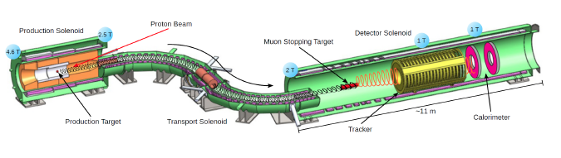
Figure 10: The Mu2e apparatus. Backward-going pions produced by the 8 GeV proton beam are captured and decay into muons transported through a bent solenoid to a series of thin aluminium discs where they stop. The electron produced in the muon decay or capture is measured by the straw tracker and by a pair of crystal calorimeters in the shape of hollow cylinders to let the low momentum electrons go through undetected. The cosmic ray veto surrounding the detector solenoid, the absorbers inside the detector solenoid, and the extinction and stopping target monitor are not shown.

PROBES researchers will develop the upgraded Mu2e-II to achieve a 10x improvement in sensitivity in three years of data taking by employing an upgraded proton source to increase beam intensity. Mu2e-II will be exposed to a 10x radiation dose with respect to Mu2e. This will require R&D to design radiation-hard detectors, including an upgraded calorimeter employing radiation-hard barium fluoride (BaF₂) crystals readout with new Avalanche Photo Diodes (APD), and electronics. The expected 3x increase in data throughput will require online data processing on FPGAs and GPUs.
New accelerator technologies for the high intensity and energy frontier particle physics experiments. PROBES researchers provide leading contributions to the international effort towards new particle accelerator technologies necessary to pursue searches for physics beyond the Standard Model at the high intensity and energy frontiers.
PSI delivers the most intense low energy continuous muon beam in the world. One beam-line serves the particle physics community by delivering up to 10⁸ μ⁺/s. It is tuned to select positive muons with an average momentum of 28 MeV/c and a momentum bite of 5-7% FWHM. A second beam-line delivers up to 5 x10⁸ μ⁺/s to serve the material science community that exploits the Muon Spin Relaxation, Rotation, Resonance (SR) technique. The request of high-intensity muon beams has stimulated new upgrades. The High Intensity Muon Beam (HiMB) project at PSI will develop new muon beam-lines with the intensity of 10¹⁰ μ⁺/s. While next-generation proton drivers with beam powers above the current limit of 1.4 MW still require significant research, the idea of HiMB is to optimize the existing target stations and beam lines. HiMB will exploit:
- an optimized muon production target. Preliminary Monte Carlo studies show that a rotated slab target has much better performance than a standard target and a 30-60 % beam intensity increase is possible. An additional gain of 10% could be achieved using novel target materials such as boron carbide.
- a higher muon capture efficiency at the production target and a higher transmission efficiency thanks to an improved design of the beam line optics based on pure solenoid elements. The total fraction of captured and transmitted muons could increase at least by one order of magnitude.
In perspective, the 50% beam intensity increase that can be achieved by optimizing the target corresponds to raising the PSI proton beam power by 650 kW, that is equivalent to a beam power of almost 2 MW. This would no imply the additional complications due to the increased energy and radiation deposition into the target and surrounding devices. The beam line optimization would produce a beam intensity that could be reached only with a beam power of the order of several tens of MW, which would be a real breakthrough.
FNAL, CERN and INFN are making great progress in the Nb₃Sn technology which has superior superconducting properties than any alternative used in existing accelerators. This innovative technology could be used also for LHC upgrades. To this aim the development of high-field Nb₃Sn magnets is required, which is challenging, since the Nb₃Sn is brittle and requires high temperature processing. With the stronger forces and stresses in the coil, the mechanical design, the study of new stress management solutions and the magnetic analysis are crucial. In 2015 FNAL has fabricated and tested the first successful Nb₃Sn twin-aperture accelerator magnet, and has started with CERN and INFN to develop high-field Nb₃Sn dipole demonstrators for a 100 TeV scale hadron collider. PROBES researchers will provide leading contribution to this international effort.
The Integrable Optics Test Accelerator (IOTA) at FNAL is a 40 m circumference storage ring and one of a handful of facilities worldwide dedicated to beam-physics studies. It forms the centrepiece of the FNAL Accelerator Science and Technology (FAST) facility, and is the first research accelerator that can switch between beams of electrons and protons. PROBES researchers use IOTA to explore multiple accelerator technologies, including several that have been proposed but never tested, in particular targeting ultrahigh-intensity beams. IOTA also allows precise control of a single electron, thus opening the door to unique experiments in fundamental physics, such as understanding the electron quantum mechanical nature, and the properties of the photons emitted by the electron stored in the accelerator. IOTA’s focus is to test the concept of nonlinear integrable focusing lattice in a realistic storage ring. Whereas contemporary accelerators are designed with linear focusing lattices, in reality machines have nonlinearities, for example resulting from magnet imperfections that lead to resonant behaviour and particle losses. PROBES researchers will capitalize FNAL’s existing strengths in accelerator technologies, such as cooling, to make more orderly beams that are easier to manipulate and accelerate. In the year 2019 FNAL team will install the proton injector to complete the trio of particle accelerators that make the FAST facility: the proton injector, the electron injector and the IOTA ring. FAST has already attracted almost 30 institutional partners, including the European institutions involved in PROBES, US universities, US national laboratories and members from industry.
2.1.4 Inter/multidisciplinary types of knowledge involved. The innovative technologies involved in PROBES have applications in other areas of basic and applied research and require innovation also at the industrial level.
Streaming Read-Out technology. Dark matter experiments at accelerators cannot rely on a reference signal provided by the machine and require clever trigger solutions. In most cases the dark matter beam is expected to pass through the detector without leaving any significant visible signal into it. The large primary charge (~10²² Electron-On-Target) needed by this kind of experiments (to make them feasible in ~1y time) requires an intense and almost continuous beam making impractical a time correlation between the accelerator RF reference and any detected final state. For BDX we will develop a full streaming read-out DAQ. A minimal threshold on crystals will determine the corresponding channel data transfer to a farm of CPU. Data recorded will be then filtered according to sophisticated algorithms (e.g. searching for a signal shower against a uniformly distributed cosmic background) that reduce the size of the stored events preserving the full information for subsequent analyses. Streaming readout is an emerging technology with broad potential applications that other state-of-the-art and world-challenging experiments (such as LHCb at high-luminosity, or CBM at FAIR) are planning to use in the near future. BDX will use a dedicated front-end electronic (a custom-designed high-performing 250 MHz, 14-bit flash ADC) together with a software infrastructure (TRiggeleres Data Acquisition Sofware or TRIDAS) inherited by the underwater neutrino experiment KM3NET.
High purity liquid argon technology. PROBES researchers will develop huge LAr-TPCs adopting innovative solutions for the argon purification systems. Electronegative impurities, mainly O₂, H₂O and CO₂, must be kept at extremely low concentrations. New industrial purification methods have been developed to filter both liquid and gas argon. A free electron lifetime exceeding 16 ms has been obtained, corresponding to a 20 ppt O₂ liquid-argon contamination. This milestone paves the way to the construction of huge detectors with longer drift distances. The development of detector prototypes to measure extremely high liquid-argon purities will be beneficial not only to DUNE, but to the European microelectronics industry which requires well-controlled, extremely high purity argon. This also allows developing new alternatives to LAr-TPC for future large LAr detectors, as the Large Electron Multipliers (LEM) derived from GEM technology. Wire planes are replaced with electrode planes with sub-millimetre circular holes where charge is channelled with no electron multiplication. The mechanical complexity and cost for such a detector could be stronglyreduced with respect to wire-based TPC for large detectors with tens of thousand channels.
Detectors for hostile environments. PROBES researchers operate particle detectors in hostile environments (e.g. cryogenic temperatures, large magnetic fields and radiation fluxes and vacuum). This limits the use of commercial devices which have to be qualified and, in many cases, re-designed. This favours the transfer of knowledge between academia and private companies. For example, MEG, ICARUS and Hamamatsu have developed large surface PMTs to operate in the liquid Xenon at -108 C and at high rate. These devices are now used in many experiments. MEG-II has replaced the PMTs with cryogenic SiPMs developed with Hamamatsu. In Mu2e the 1T magnetic field and the radiation levels require unconventional alternatives to standard electronics components. The new radiation-hard PolarFire series FPGA from Microsemi Corporation has been adopted. The Mu2e calorimeter has required the development and qualification of radiation-resistant and magnetic field compatible SiPM readout and digitization electronics. The new technology can be applied to medical imaging, in the combination of PET and MRI, including ultra-high field MRI.
Radiation monitoring devices. The Mu2e STM detector must record X-rays at very high rate in a high radiation environment whilst maintaining good energy resolution. Typically, such detectors only satisfy one or two of these criteria: a detector satisfying them all has applications to monitoring reactors and nuclear materials, which is important to monitor nuclear waste non-proliferation, and the safe operation of targets in high intensity proton beams which has relevance to next generation neutron-spallation facilities. Highly segmented HPGe detectors such as the one being designed for Mu2e can be used to non-destructively assay highly-radioactive spent reactor fuel-rods using the ¹³⁴Cs/¹³⁷Cs ratio to determine the fuel history (i.e. burn-up and cooling time). Such high-rate detectors (operating above 1 MHz) are required since operating at lower-rates increases the time on site generally incompatible with the operation of the facility. MEG-II is developing a new generation of beam monitoring detectors based on scintillating fibres and SiPM to provide an online (<10 s) measurement of beam profiles and rates. The new detectors operate in high magnetic fields and beam intensity (10⁸ particle/s) and perform muon/electron/pion identification. As a spin-off of the new technology, the PSI particle and medical physics groups have successfully developed a first prototype of an “in-vivo” dosimeter for the PSI cancer therapy center.
Particle accelerator technology. Many thousands of accelerators serve as essential tools for biomedical and materials research, for diagnosing and treating illnesses, and for a growing host of tasks in manufacturing, energy technology and homeland security. Advances in proton and ion beam therapy are enabling doctors to avoid harming tissue near the cancer. Electron beams, or X-rays derived from them can kill bacteria like Escherichia coli, salmonella and listeria. Food irradiation is gaining approval in various countries including the US, although consumer acceptance has been slow, since the work “irradiation” makes people wary. This technology can be used to sterilize products, for example plastic supplies like catheters or cloth bandages. Accelerators offer several options to scan cargo containers and vehicles. This is fundamental for homeland security and allows inspecting cargo containers arriving at ports on ships from foreign countries. The semiconductor industry relies on ion beams to add special atoms in semiconductors. Ion implantation modifies semiconductors’ electrical properties leading to better, cheaper electronics. It is also used to produce hard surface layers, with greater toughness and less corrosion, and produce longer lasting prosthesis, like artificial hip or knee joints, high-speed bearings, and cutting tools. Intense and bright X-ray beams reveal details of the arrangement and behaviour of atoms and electrons in complex materials and have become crucial for basic and applied research in biology and medicine, materials and chemical sciences, geosciences and environmental sciences.
High Performance Computing (HPC) and Machine Learning techniques. The European Community and the US Government are making large investments in HPC systems, which are crucial for the progress of science and a strategic resource for the future. Europe will have to out-compute to out-compete and the tight collaboration with US centres will be fundamental to master advanced technologies. FNAL is leading the effort to provide computing infrastructures to the Intensity Frontier experiments and advancing plans for a scientific data archive facility to host scientific data for a wider range of disciplines. It is home to one of the largest tape robotic systems and provides more than 500 petabytes of storage capability. It also has the technology to process these data in a timely fashion. HPC will provide the resources required for the next generation of HEP analysis and will be fundamental in many computation-intensive research areas, including basic research, engineering, earth and materials science, climate science, medical imaging, energy and security. Machine Learning techniques are pursued to reconstruct the challengingly detailed neutrino events. Convolution neural networks or semantic segmentation networks are examples of methods that have been employed. These techniques have industrial applications: self-driving cars, image recognition, virtual personal assistant, social media and finance. With the incorporation of sensor data processing in a control unit in a self-driving car, it is essential to enhance the utilization of Machine Learning to accomplish new tasks. Potential applications include evaluation of driver condition or driving scenario through data fusion from different sensors, like lidar, radars, cameras, or the Internet of Things.
High-Level Synthesis (HLS) tools and Heterogeneous Computing (HC). These emerging technologies have important scientific, industrial and commercial impact. Synthetizing from the C or C++ languages offers accrued abstraction, expressing power and coding flexibility. Important companies as Xilinx, Synopsis, NEC, Cadence, Altium, Altera, INVIDIA, Google Qualcomm and academic institutions have developed HLS compilers to achieve new levels of design productivity. HLS techniques have applications in contexts where data acquired from hardware are processed in real time. Markets that need computer vision and deep learning for image processing such as medical, security, industrial and automotive, are growing at a phenomenal rate. However, the algorithms to teach a computer to “see and understand” require huge amount of parallel computing performance and devices “at-the-edge” with low power requirements. FPGAs and ASICs meet these requirements for acceleration but traditional register-transfer level development takes too long and does not adapt to the rapid change in specifications and algorithms these markets require. One of the most obvious benefits is that HLS tools automatically analyse the structure of the algorithms to extract the algorithms data and control flow paths, and find the processing bottlenecks. With the tremendous level of particle detectors complexity and data throughput, particle physics experiments offer ideal test opportunities for these technologies. Industry will benefit from the experience gained from these applications to offer more performing products to the market.
2.1.4 Gender aspects. PROBES participants are aware of the problem of pipeline shrinkage for women especially in science and engineering, in academia as well as outside academia. Gender composition of the WP coordinators, of the Management Board and Scientific Board and at all decision-making levels will be balanced. Senior researchers will mentor female researchers as future senior leaders of research groups. One member of the PROBES Management Board will be appointed as an Equal Opportunity Focal Point. We will also achieve family-friendly working conditions. We will promote female speakers at the training events, workshops and conferences. The success of these measures will be monitored by checking the success rates of female applications for promotions over the PROBES four-year duration.
Table B1 – Work Package (WP) List
Work Package No | Work Package Title | Activity Type | Number of person-months | Lead Beneficiary | Start Month | End month
1 | Hadron Physics: Detectors | Research, Training | 85 | INFN | 1 | 48
2 | Hadron Physics: Data Analysis | Research, Training | 97 | UGLS | 1 | 48
3 | LFV experiments: Detectors | Research, Training | 123 | IMC | 1 | 48
4 | LFV experiments: Data Analysis | Research, Training | 121 | UNIPI | 1 | 48
5 | Particle Accelerator Technology | Research, Training | 44 | PSI | 1 | 48
6 | Dissemination and Outreach | Dissemination, Communication | 0 | CNRS | 1 | 48
7 | Transfer of Knowledge | Training, Dissemination | 0 | CERN | 1 | 48
8 | Management | Management, Communication | 0 | UNIPI | 1 | 48
2.2 Quality and appropriateness of knowledge sharing among the participating organisations in light of the research and innovation objectives
To maximize knowledge sharing, PROBES will second researchers as much as possible, organize internal workshops and training sessions, and strongly encourage participation in specialized workshops, trainings, schools and conferences according to the open science model developed by CERN. Relevant information and documents will be made available to all participants through the internal section of the PROBES web site.
Secondments. Secondments will maximize the collaboration and knowledge sharing among the participants with leading roles in the construction and data analysis of the JLAB, FNAL, PSI and J-PARC experiments. Successful detector development and data analysis will be the product of a continuous interaction among EU, US and Japan researchers. Secondments will be crucial for detector commissioning and operation, data taking and analysis, and will allow PROBES researchers to acquire leading roles also in the development of the computing infrastructures. Early Stage Researchers (ESR) in particular will receive invaluable training during the commissioning and data taking of the experiments. In order for this to be more effective, an effort will be made to have ESRs seconded for at least 4 o 5 continuative months.
Workshops. PROBES workshops will be organized once a year in coincidence with the General Meetings to have a general review of the PROBES research activity. For each Work Package one dedicated session will be organized with talks, presentations and detailed discussions of the achieved results and prospects. Participation in person will be strongly encouraged although remote participation will be possible.
Training sessions. Trainings will be crucial to optimize the transfer of knowledge among participants. Specific trainings will be organized by the host institutions to transfer all the necessary technical skills at the beginning of each secondment. Local personnel at JLAB, FNAL, CERN and J-PARC will train seconded researchers to use specialized infrastructures, mechanical equipment, electronics shops and computing resources and will provide the appropriate hazard and safety trainings. The fraction of secondments of personnel employed by private companies (CAEN, CLEVER, SEEMS) is significant: researchers of the academic institutions will provide training on a case-by-case basis on the technologies employed in particle physics research.
In coincidence with the annual PROBES General Meetings, one-day Training sessions will be organized on the most advanced technological challenges involved in PROBES research activities:
- Year 1: Training session dedicated to High-Performance Computing and Machine Learning applied to particle physics experiments data processing and analysis;
- Year 2: Training session dedicated New Developments in Particle Accelerator Technologies;
- Year 3: Training session dedicated to the design and qualification of radiation-hard electronics for particle detectors employed at the high intensity frontier particle physics experiments;
- Year 4: Training session dedicated to entrepreneurship and project management, research valorization and innovation to foster innovation an entrepreneurial mind-set in academic researchers. Top-level experts in innovation and technology transfer will be invited.
PROBES will encourage participation in schools organized by the wider particle physics communities. Some examples are reported in the following. The International Neutrino Summer School provides training in theory and experiment in neutrino physics. The school brings together graduate students and postdocs, and the best teachers and researchers in neutrino physics, to create an intense learning experience that covers the full range of modern neutrino physics. The FNAL Liquid Argon Software (LArSoft) Collaboration develops a shared base of physics software resources for event simulation, reconstruction and analysis across LAr-TPC experiments, and FNAL organizes training and workshops on this common platform for new users. The EIC eRD23 R&D Consortium aims to develop a full streaming readout framework for the future Electron-Ion Collider data acquisition. In this context, the activity of PROBES collaborators involved in light dark matter search represents a stimulating environment to test new technological solutions as well as a valuable playground to train young scientists for future challenges. The INFN-LNF Spring School in Nuclear, Subnuclear and Astroparticle Physics trains young researchers in the fields of accelerators, future detectors, trigger and data-acquisition, future colliders, dark matter and astro-particle experiments, neutrino theory, cosmological surveys, heavy flavor and heavy ions physics, Higgs measurements, Beyond SM theory and searches. The FNAL High Energy Physics Software School trains young researchers with limited experience in developing software within the framework of large computing projects. In the field of particle accelerators, the U.S. Particle Accelerator School, Education in Beam Physics and Accelerator Technology, and the CERN Accelerator School provide trainings for young researchers.
Conferences. PROBES researchers will be strongly encouraged to participate in International Conferences to present the new PROBES scientific results and be informed of the progress in related research areas.
2.3 Quality of the proposed interaction between the participating organisations
PROBES is the natural development of the long-standing collaboration and growing synergy among the participants: for the European (CERN, PSI), US (JLAB, FNAL, LBNL) and Japanese (J-PARC) laboratories the collaboration with the European universities dates back to their foundation, with an interminable history of successful particle physics experiments.
2.3.1 Contribution of each participating organization in the activities planned.
Hadron physics experiments at JLAB. PROBES researchers have a prominent role in the 3D study of the nucleon. INFN was deeply involved in the precursor HERMES experiment, which published several first observations and contributed to the growth of this new field of research. INFN had the responsibility of the polarized gaseous target inside the HERA beam-pipe and contributed to the construction of the RICH detector for hadron identification. INFN is co-sharing the responsibility of the GEM tracker and hadron calorimeter of the SBS spectrometer in Hall-A that will enter into operation in 2020. INFN is leading the construction of the CLAS12 RICH detector to access flavour information, whose completion is foreseen in 2021, before the starting of experiments with polarized targets in Hall-B. INFN is collaborating with JLAB for the research and development of a transversely polarized target, possibly based on the innovative cryogenic HD-ice and bulk-superconducting technologies, for dedicated experiments in 2022 and beyond. CNRS and CEA have been studying hard exclusive reactions since the pioneering works with 6 GeV beam at JLAB. CEA has realized a micro-megas tracking system and CNRS a neutron detector for the central region of CLAS12, designed to identify the recoiling nucleon in hard exclusive reactions. UGLS is contributing to the SBS construction and CLAS12 experiment. PROBES researchers are co-spokespersons of approved JLAB experiments using both CLAS12 and SBS spectrometers. INFN has promoted the dark matter program at JLAB as part of the HPS Collaboration and is leading the BDX experiment now entering in a preparatory phase of pilot measurements. CNRS is contributing to the HPS experiment. INFN has pioneered the hypernuclear program at JLAB and share co-spokesperson positions in PREX experiment. JLAB provides the laboratory infrastructure, the world-leading highly polarized electron beam and a world-class experience in polarized targets.
Short Baseline Neutrino experiments (SBN) at FNAL. INFN, CERN and UNIBE have pioneered and developed LAr-TPC technology for the last 20 years and have established a strong collaboration with the US Partners FNAL, YALE, MIT and LBNL to pursue the FNAL SBN and DUNE physics programs. INFN has developed LAr-TPC technology to full maturity through the construction and operation of the ICARUS T600 detector at LNGS, the largest LAr-TPC ever built and acquired a deep experience in reconstructing neutrino events from CNGS neutrino beam. ICARUS underwent an intensive overhauling by INFN and CERN before being shipped to US. Developments have been introduced on cryogenics and liquid argon purification systems, light detection system and the electronic read-out fully redesigned by INFN and CAEN. INFN has also investigated a possible alternative to wire planes in LAr-TPCs represented by LEM (Large Electron Multipliers) derived from the GEM technology used in double-phase liquid Argon TPCs. UNIBE has also developed the Cosmic Ray Tagger (CRT) and the UV-laser calibration system of the LAr-TPC for MicroBooNE and SBND. This expertise has been crucial to design the ICARUS CRT composed of ~1000 m² of segmented plastic scintillation counters built by CERN, INFN and FNAL. FNAL provides laboratory infrastructure and world-class expertise in detector development, construction, installation, commissioning and operation, and in-house skills in project management and high-level organization of large experiments. FNAL and CERN provide computing infrastructures for data taking and analysis. The CERN Neutrino Platform contributes to research in neutrino physics at particle accelerators as recommended by the 2013 European Strategy for particle physics. It includes the provision of a facility at CERN to allow the community of neutrino experts to develop the next generation of neutrino detectors. MIT, YALE and LBNL have been deeply involved in the SBN experiments design and construction and in studies of the sensitivity of the SBN program. Just to make some examples, YALE has developed the LAr-TPC field shaping system of SBND and is introducing novel solution based on Machine Learning technologies to the neutrino event reconstruction. PROBES researchers will take leading roles in data taking and analysis.
CLFV experiments at FNAL (Mu2e), PSI (MEG-II and Mu3e) and J-PARC (COMET). INFN and UNIPI are responsible for the design and construction of the Mu2e electromagnetic calorimeter in collaboration with FNAL and Caltech. This includes R&D of crystals and photo-sensors, electronics, mechanical structures, the qualification of the components in high levels of radiation, magnetic field and vacuum, detector integration in the experimental area, along with simulation and development of calibration and reconstruction code, in collaboration with FNAL, YALE and LBNL. PROBES researchers will take leading roles in the detectors construction and commissioning in 2020 and 2021, and data taking and analysis in the following years.
UNIPI, INFN, and PSI are leading the effort towards MEG-II and Mu3e. PSI provides the laboratory infrastructure, the most intense muon beams and a world-class experience in detector development and operation. INFN and UNIPI have developed the new highly transparent MEG-II drift chamber and the entire trigger system in collaboration with UTOKYO. INFN, UNIPI and PSI have also designed the Mu3e experiment and are developing the pixel and scintillating fibre tracker and the entire trigger and data acquisition systems. They will take leading roles in the commissioning of the MEG-II and Mu3e detectors, data taking and data analysis, including the feasibility studies for exotic searches.
IMC, CNRS, GUT, TUD and UOSAKA have designed and are building the COMET experiment at J-PARC. IMC accelerator physics group strongly contributes to the development of the J-PARC accelerator chains, and the electronics group is developing the COMET DAQ system. IMC also collaborates with UOSAKA to build the COMET DAQ and Slow Control systems. CNRS provides leading contribution to software reconstruction algorithms, large-scale high-performance computing and storage provision, with the IN2P3 Computing Centre in Lyon being the main COMET data centre, radiation modelling, theoretical and phenomenological studies and the design and construction of thin glass-based resistive plate chambers for the Cosmic Ray Veto as well as the electronics of the detector. GTU is building scintillator-based Cosmic Ray Veto modules and contributes to the construction of the Straw Tracker and Electromagnetic Calorimeter. TUD is responsible for the design and construction of the muon stopping target and the accompanying X-ray Monitor that observes the target. PROBES researchers will participate in the analysis work, both in relation to the areas of the experiment they are responsible for, and more generally towards the COMET physics measurements.
New accelerator technologies. PSI, INFN, UNIPI and UOSAKA will develop the new High Intensity Muon Beam project at PSI to increase the current muon beam intensity by a 20x factor for future CLFV searches, including an upgraded Mu3e and beyond. INFN, CERN and FNAL are developing the Nb₃Sn technology to build superconducting magnets for future particle accelerators, including LHC upgrades. FNAL is world leader in this technology and is transferring the know-how to CERN and INFN. CAEN, CLEVER and SEEMS will develop electronic test systems. CERN and INFN will exploit the IOTA infrastructure at FNAL to perform studies of nonlinear integrable optics to control and stabilize high-intensity and high-brightness particle beams and enable next generation of rare-decay and neutrino experiments. INFN will use IOTA to test and assess sensitivity of innovative single-photon imaging detectors and also measure the spatial and temporal distribution of synchrotron radiation from single circulating electrons.
3. Impact
3.1 Enhancing the potential and future career prospects of the staff members
PROBES will develop the potential of a new generation of European scientists with a global approach through exposure to both US and Japanese research and industrial environments. Secondments in US and Japanese Universities and laboratories and intersectoral secondments in Europe will offer a unique opportunity to work in a world-class environment of academic and non-academic partners, and provide access to a broad area of expertise and superior career prospects in academia and industry. Secondments will favour future work opportunities with fellowships or contracts as already executed at JLAB, FNAL and CERN. PROBES is at the frontier of technology in many areas: particle radiation detectors for high-intensity accelerator beams, radiation-hard and magnetic-tolerant analog and digital electronics, photo-sensors for high energy physics and medical applications, laser calibration systems, simulations of radiation transport, advanced particle accelerators technologies, high-speed computing infrastructures, complex analyses of large datasets. Young researchers will be involved in the full life-cycle of the experiments from the beginning, through the hardware commissioning, to the running of the experiment and the optimization of the reconstruction and analysis tools and the completion of data analysis. PROBES is an ideal opportunity for ESRs to get a PhD in particle detector construction and data analysis and to present their results at workshops and international conferences. The expected success of this collaboration between US, Japan and Europe has its roots in the extraordinary success of the many international collaborations which have developed successful experiments at CERN, FNAL, JLAB and KEK. The merging of academic with non-academic partners will be beneficial to reinforce the European industrial innovation capacity.
It is commonly felt that over-specialization in HEP makes it difficult for young researchers to get exposed to a broad variety of experimental techniques. As an example, a typical researcher in experimental HEP can spend several years only performing data analysis, or developing a single instrument for the purpose of upgrading one single sub-detector in a complex apparatus, and it is uncommon for a PhD student to be active on both. Somewhat paradoxically, however, academic faculty positions are preferentially assigned to the few candidates who manage to acquire a “complete profile” (i.e. from hardware to data analysis) during their doctoral and postdoctoral experience. PROBES will make every possible effort to involve ESRs in relatively small teams that control every aspect from instrumentation to high-level analysis and interpretation. The plurality of skills acquired by the ESRs and young ER will greatly enhance their prospects on the academic job market (at various steps in their future careers, from post-doctoral research contracts to faculty positions) and in the private R&D sector with respect to their peers who did not enjoy comparable opportunities.
3.2 Developing new and lasting research collaborations, achieving transfer of knowledge between participating organisations and contribution to improving research and innovation potential at the European and global levels
3.2.1 Development of new and lasting research collaborations. While the researchers from the European Institutions leading PROBES represent 15% of the COMET, 20% of the CLAS, 20% of the MicroBooNE, 30% of the SBND, and 15% of the Mu2e Collaborations, they have not yet reached a commensurate level in terms of leadership, coordination roles and visibility. This is the consequence of their limited permanence at the US and Japanese laboratories. PROBES will boost such opportunities and will open new career prospects to the involved researchers that will be fundamental in developing new collaborations. The US is pursuing a near-term, world-leading short-baseline experimental neutrino program with strong participation by domestic and international neutrino communities working towards a long-baseline neutrino program hosted at FNAL. The DUNE Science Collaboration is currently made up of over 1100 collaborators from almost 180 Institutions in over 30 countries plus CERN. The LAr-TPC technology will be central to this program and a continuous presence of PROBES researchers at FNAL with leading roles within the SBN experiments will allow them to play a fundament role over the next decades in this global neutrino physics community working toward DUNE. PROBES researchers involved in COMET Phase-I at J-PARC will be in the best position to take leading roles in the development of COMET Phase-II. PROBES researchers involved in Mu2e will be able to participate in Mu2e-II that with new advanced detectors will exploit the increased proton intensity of the FNAL accelerator to improve the sensitivity for neutrinoless muon-to-electron conversion by one order of magnitude beyond Mu2e. This will provide the deepest probe of charged lepton flavor violation in the foreseeable future and PROBES researchers will play a leading role. PROBES will increase the transfer of knowledge from the US and Japan to Europe. This will be extremely beneficial especially to the future careers of both ESR and young ER at academic as well as non-academic institutions. The inter-sectoral secondments from and to European SMEs will reinforce the collaboration and transfer of knowledge.
3.2.2 Self-sustainability of the partnership after the end of the project. The established partnership will continue after the end of PROBES. The JLAB, FNAL, PSI and J-PARC experiments will be active and the European research institutions will receive financial support from their national funding agencies well beyond the PROBES lifetime e.g. for the participation in DUNE , Mu2e-II and COMET Phase-II.
3.2.3 Contribution of the project to the improvement of the research and innovation potential within Europe and/or worldwide. PROBES will create new international collaborations and reinforce the existing ones between US, Japanese and European institutes. This will increase the innovation capacity in Europe, through the leadership in the development of challenging particle physics experiments at JLAB, FNAL, PSI, and J-PARC and new accelerator technologies, state-of-the-art detectors and infrastructure for particle physics experiments, electronics and sensors and high-speed computing. The collaboration between US, Japan and Europe will continue after the end of PROBES, when all experiments will be focusing on data analysis and, for some of them, the implementation of upgrades. Merging academic with non-academic partners will be beneficial to the training of the researchers and to reinforce the European industrial innovation capacity. The transfer of knowledge from the US and Japanese laboratories will improve the innovation potential of the involved SMEs. Secondments of researchers of these companies at Academic Institutions provide an excellent opportunity for hands-on training.
3.3 Quality of the proposed measures to exploit and disseminate the action results
3.3.1 Dissemination strategy. To maximize the visibility of PROBES results in the scientific community we have a strong dissemination plan. PROBES web site will provide access to the project information, scientific publications, public deliverables and organized events. Results will be presented at international/national conferences/workshops where representatives from industry are frequently present to facilitate contacts with companies working in the field. The CLAS, SBN, COMET, MEG-II, Mu3e, and Mu2e Collaborations all have an internal “Speakers Committee” responsible for negotiating invited talks with conference organizers and seminars at major physics laboratories, and for ensuring the Collaboration is well-represented with talks divided fairly among the Collaboration and that presentations are of the highest possible quality. The membership of the Speakers Committee is selected to broadly represent the Collaboration in terms of the different detector and analysis subgroups, and each member state. The objective is to ensure the Collaboration is presented in the best possible light and for all members to be treated equitably, with a special consideration for younger members seeking employment. PROBES researchers are eligible to be and in some cases are members of these Committees. They will adopt this policy to maximize the dissemination of PROBES results. Some of the most relevant conferences are the EPS Conference on High Energy Physics, ICHEP, the International Symposium on Lepton and Photon Interactions at High Energies, the International Conference on CLFV, and several instrumentation conferences. PROBES results will be published in peer-reviewed journals according to the guidelines for publication of the involved Collaborations. Each Collaboration has an internal “Publications Committee” to monitor the internal approval process of all publications and physics results and to help ensure a high standard, achieved by broad peer-review within the Collaborations, while ensuring the timely availability of physics results. PROBES researchers are eligible to and in some cases are members of the Publications Committees. The most relevant journals are: Physical Review Letters, Physical Review, Physics Letters B, Nuclear Physics B, Journal of High Energy Physics, The European Physical Journal, Journal of Instrumentation, IEEE Transactions on Nuclear Science, IEEE Transactions on Applied Superconductivity, Superconductors Science and Technology, Materials Letters, Nuclear Instruments and Methods in Physics Research A, Physics of Plasmas, Physical Review Accelerators and Beams, Nature, Science. All publications will be available in open access repositories such as arXiv.org and the PROBES web site. Social networks, including Facebook, Twitter and LinkedIn will also be used. If a consortium partner should claim intellectual property rights which do not allow for a (early) dissemination of the results, the Management Board will make a decision according to the Consortium Agreement. The dissemination among university students will be supported by initiatives such as Summer Schools. Besides the CERN, PSI and KEK Summer Students Programs, UNIPI, INFN and FNAL organize the “Summer School at FNAL and other US Laboratories”, a 9-week internship accessible to students of European Universities. Students perform an original research activity under the supervision of a scientist of the host laboratory. The school provides 6 ECTS credits upon successful completion of the final exam with a UNIPI, INFN and FNAL committee.
3.3.2. Expected impact. Our plan of “internal” dissemination will favor the communication of our scientific results among all PROBES participants, and the “external” dissemination plan will have a strong impact on the entire scientific community, and on the younger generations of European university students in scientific and technological disciplines.
3.3.3. Exploitation of results and intellectual property. PROBES research institutions will establish close collaborations with the private sector, the impact of which will be measured by the quality of the scientific achievements. All results will be published promptly and made accessible to the scientific community. Maximum effort will be made to export the new developed detector technologies to future experiments. The public and private sector partners will cooperate closely to develop industrial applications of the developed technologies. Rules for the protection of the Intellectual Property will be addressed to establish a framework for the protection of applications also through patent application.
3.4 Quality of the proposed measures to communicate the action activities to different target audiences
3.4.1 Communication strategy and outreach plan. PROBES participants can rely on efficient structures and a strong tradition in science communication. They will work in synergy with the existing communication offices to engage the public. New actions about PROBES will be developed and directed to many audiences, including the general public and schools. We will integrate our activities with the most successful ones already in place in the US, particularly targeting young generations. Our outreach program will promote European research and innovation, stimulate a broader public awareness and understanding of science, and engage young people to pursue careers in STEMs. In the PROBES early stages we will focus on raising awareness among the community, then as first PROBES results become available, dissemination will begin and last until the end of the PROBES period. In the last PROBES quarter, we will disseminate results to the wider audience to facilitate future research activities. We will benefit from the long-standing CERN, PSI, JLAB, J-PARC and FNAL tradition in outreach. A lot of material is already available: online web pages and brochures describing the laboratories’ mission, as well as providing information on the most relevant achieved results. The J-LAB and FNAL Education and Public Outreach teams in US are very successful in disseminating scientific and educational material. Several online activities have been developed including interactive applications. CERN provides within the Education, Communication and Outreach Department, press releases, online communications, exhibitions and outreach, teacher and student programs and visits as well as the established Summer School. We will use these resources to better engage the European public, including schools. We are already involved in the European Researchers Night and are extremely active in the organization of Masterclasses for high-school students and Open Days to laboratories for the local communities and schools. In coincidence with the European Researchers Night we open our laboratories to the general public to show the products of their research activity, including prototypes of particle detectors. We will increase our participation in these events and will prepare posters describing the importance of research in particle physics, showcasing the many applications in applied technology. We will also organize new outreach activities devoted to high-school teachers, for example at the annual “Incontri di Fisica” (“Physics Meetings”) at the INFN Laboratories in Frascati. This has a high visibility since modern physics is now included in all high-school programs. We will contribute to initiatives in science communication for the general public in Italy, like the Open Days of the LNL Legnaro, LNGS Gran Sasso and LNF Frascati. The yearly “Sperimentando” initiative, organized by INFN and Padova University, will offer a great opportunity to attract general public and students in Italy, from primary to undergraduate level, with lectures and active experimental interactions. We will be involved also in the “school-work” stages for secondary school Italian students. In coincidence with the annual PROBES General Meetings, which will be organized at a different Institution each year, we will give lectures to university students. PROBES laboratories will be open for demonstrations. The representatives of the non-academic Institutions will be available to discuss the prospects in research and development in industry. With these initiatives, PROBES will contribute to clarify the impact of fundamental science on society, which is often under-appreciated or believed to be only for the long term.
Web site. A fundamental tool will be the PROBES web site, which will contain the relevant scientific material, the links to the many associated web sites and the agenda of all the above mentioned public events promoted by the PROBES participants. The web site will be maintained for at least one year following the end of the project in order to increase the project’s dissemination and impact. We will produce brochures and flyers to present PROBES objectives and activities to be handed out at each public event. They will also be distributed online as clear and appealing info-graphics, that can be easily spread through social networks and interested websites. We will also produce and display info-graphic videos on wide screens at events, to promote the objectives, challenges and main outcomes of the projects and to show to the young generations how exciting a career in science can be. The videos will be shared on the website and on social networks. Every six months a newsletter will be issued describing the development of the projects. Each participating institution will also involve the media in their country with press releases and interviews.
Social media. We will exploit social media to maximize PROBES impact beyond the specialized community. We will show to the general public, especially to the young generations, how society can benefit from research, and that it is possible to build a career in research. We will develop a communication strategy at consortium level based on the most common platforms (Twitter, Facebook, LinkedIn, YouTube). We will create the PROBES social media accounts as soon as it starts and the accounts of the beneficiary organizations will act as multipliers of information. One person will oversee all this at consortium level, setup and manage social media accounts, centralize the information to be shared and communicate with the audience, including replying to messages. PROBES researchers who are already using social media will share the posts and relevant content with the appropriate audiences. For example, we will post about PROBES breakthrough results, presentations at international conferences, participation at outreach events, and meetings with US and Japanese collaborators and associated social events. We will connect with other H2020 beneficiaries by following their accounts, replying to their posts to attract each other’s followers and fans and enlarge PROBES community. We will connect to similar initiatives in US laboratories and universities. We will play an active role in H2020 communication and dissemination campaigns launched by the European Commission. A connection between PROBES social media and website will be created by posting also on the website. All the offline information, e.g. brochures, leaflets and flyers will include reference to the online sources. We will take into account the risks involved in using social media, including privacy and data breaches, information leakage, security breaches and targeted spam. We will measure the impact by taking into account quantitative and qualitative indicators and we will adjust style, content and tone to hold the reader’s attention.
3.4.2 Expected impact. The proposed communication strategy is aimed at giving visibility to PROBES to a variety of audiences, but particularly high-school students and the general public. We plan to work in the dissemination of physics in schools through a continuous interaction with teachers demonstrating how our researchers fit into the context of modern physics. The proposed activities will offer unique opportunities for students to get in contact with researchers from academic as well as non-academic institutions.
4. Quality and efficiency of the implementation
4.1 Coherence and effectiveness of the work plan, including appropriateness of the allocation of tasks and resources
4.1.1 Consistency and adequacy of the work plan and the activities proposed to reach the action objectives. PROBES is structured in 8 Work Packages (WPs) to provide an appropriate balance among the relevant activities and to ensure the work is efficiently organized. WP1 and WP2 are dedicated to the detector development, commissioning and data taking and analysis of the JLAB particle physics experiments: commission and operate the upgraded CLAS12 detectors and SBS spectrometers, upgrade and operate the HPS experiment, research and develop the new BDX detector and run pilot dark matter experiments with demonstrators. WP3 is dedicated to the development, commissioning and operation of the FNAL, PSI and J-PARC experiments dedicated to the study of lepton flavor violation: SBN and Mu2e at FNAL, MEG-II and Mu3e at PSI and COMET at J-PARC. We are providing leading contributions to the design and construction of these experiments and will maintain this leadership in the commissioning, operation and data taking. WP4 is dedicated to the analysis of the SBN, Mu2e, MEG-II, Mu3e and COMET data and publication of physics results. We will provide a breakthrough in the lepton flavor violation sector by performing searches for sterile neutrino using SBN data, for the μ⁺→ e⁺γ and exotic decays at MEG-II, for the μ⁺→ e⁺e⁻e⁺ decay and exotic decays at Mu3e, and for the μ⁻ N(A,Z)→ e⁻ N(A,Z) conversion at COMET and Mu2e. WP5 is dedicated to the development of new particle accelerator technologies. This includes the new high intensity muon-beam-lines at PSI for future precision muon based experiments, new low temperature and high temperature superconducting materials and magnets for future particle accelerators, and advanced beam physics researches at the new test accelerator infrastructures at FNAL. WP6 is dedicated to outreach and dissemination, WP7 to the transfer of knowledge, and WP8 to management.
4.1.2 Credibility and feasibility of the project through the activities proposed. The proposed activities are embedded in the research programs of the international collaborations: CLAS, SBS, BDX and HPS at JLAB, SBN, and Mu2e at FNAL, MEG-II and Mu3e at PSI and COMET at J-PARC. The schedules have been extensively peer-reviewed and approved by JLAB, FNAL, CERN, PSI, J-PARC, European, US and Japanese funding agencies. The proponents have a strong track-record in successfully managing and achieving the milestones in similar projects.
4.1.3 Credibility and feasibility of the allocation of secondments proposed to reach the action objectives. PROBES Institutions and researchers have a long-standing experience of international collaborations. Most researchers already spend a significant fraction of their time at the US and Japanese laboratories. PROBES will allow increasing their permanence. The plan of secondment is based upon experience and is very credible.
Table B2: Work Package Description
Work Package Number | 1 |  | Start/End Month |  |  | 1/48
Work Package Title | Hadron Physics: Detectors (Research, Training)
Lead Beneficiary | INFN
Participating organisation Short Name** | INFN | CNRS | UGLS | CEA | SRV | JLAB | MIT
Total Person Months per Participating organisation: | 58 | 10 | 7 | 8 | 2
Objectives: Commission and operate the upgraded CLAS12 detectors and develop triggers for physics and calibration datasets. Commission, optimize performance and operate the upgraded BB/SBS spectrometers in JLAB Hall A. Develop and operate detectors (HPS and BDX) for light dark matter searches.
Description of Work and Role of Specific Beneficiaries / Partner Organisations
T1.1: Commission CLAS12 RICH detector and reconstruction software and quantify detector performance (20M, INFN, CNRS, CEA, JLAB). The CLAS12 detector started data-taking in 2018 with unpolarized targets and incomplete equipment. Polarized target runs are foreseen to start in 2021. PROBES researchers will take leading roles in the following tasks: a) Upgrade the CLAS12 detector with a ring-imaging Cherenkov detector b) Develop polarized targets compatible with the CLAS12 central detector c) Develop algorithms of particle identification d) Study, prepare and validate the various configurations needed for the approved experiments e) Study the match between forward and central detectors, i.e. between current and target fragmentation region f) Study efficiency as a function of the background rejection g) Integrate the small-angle calorimeter information, to increase the discrimination efficiency and reject radiative background.
T1.2: Optimally operate upgraded BigBite and new SBS spectrometers at JLAB Hall-A (16M, INFN, UGLS, JLAB). The upgraded BigBite (BB) spectrometer will be installed in Hall-A in 2020. The new Super BigBite (SBS) spectrometer will be completed by 2021. PROBES researcher will take leading role in installation, commissioning and operation of the SBS sub-detectors and in technical and physics runs coordination: a) Commissioning of the GEM based front-tracker expected to sustain up to 10³⁹ cm⁻² s⁻¹ luminosity b) Commissioning of the highly-segmented hadron calorimeter HCAL-J to be used as trigger c) Commissioning of the silicon vertex detector d) Optimization by data (calibration and physics runs) the alignment (<100 micron resolution) procedures of the hybrid tracker e) Optimization of the working conditions in high background level (up to few 100 MHz/cm² particle flux) f) Finalization of the real-time trackers data reduction to sustain the expected trigger rate, also properly combining the information from the timing hodoscope and HCAL-J calorimeter.
T1.3: Commission light dark matter detectors (15M, INFN, CNRS, JLAB). PROBES researchers have a leading role in the following tasks: a) Operate and calibrate the HPS PbWO electromagnetic calorimeter for the dark photon search, b) Design and build a high-density crystal-based electromagnetic calorimeter to be used as active interaction volume for light dark matter searches. CsI(Tl) crystals formerly used in BaBar em calorimeter will be refurbished with modern SiPM to provide charge and time (at the level of ~ns) information, c) Design a high efficiency hermetic veto system to identify and reject cosmogenic and beam-related background. d) Design, deploy and operate a BDX-MINI detector to collect data providing the first physics reach of the experiment. The detector uses 44 PbWO crystals surrounded by plastic scintillator vetos. e) Develop and validate a Monte Carlo simulation framework to study the interaction of 10²² electrons–on-target (EOT), whereas a brute force approach could not exceed 10¹³-10¹⁴ EOT using the whole JLAB computing resources. f) Develop data analysis algorithms to identify weak signals over overwhelming background. Using the expertise developed in the other PROBES WPs, we’ll apply sophisticated Machine-Learning algorithms to identify the fable dark matter signal over the cosmic background. Exploiting directionality (the dark-matter beam propagates from the beam-dump producing an em shower going forward) and specific signatures of the em shower development vs. hadronic shower, it will be possible to distinguish neutral-current neutrino DIS interaction from genuine DM-electron interaction.
T1.4: Develop the apparatus for hypernuclear spectroscopy program at JLAB: spectrometer and PID package design and commissioning (8M, INFN, JLAB). The hypernuclear spectroscopy program at JLAB needs a high resolution apparatus in order to obtain sub-MeV missing mass energy spectrum resolutions. Two High Resolution Spectrometers, called HRS and HKS and used in previous hypernuclear spectroscopy experiments at JLAB Hall A and Hall C respectively, already exist. PROBES researchers will be involved in the software simulations needed to design the septa to be placed in front of HRS and HKS in order to separate the scattered electrons and the electro-produced kaons at small forward angles and in the commissioning of the aforementioned septa. The need to perform the experiment at very forward scattering angles, in order to compensate for the reduction with the Q² of the cross section of the electro-production of hypernuclei, requires a very sophisticated Particle IDentification system in order to distinguish the kaons from the enormous background made up of protons and pions. PROBES researchers will be involved in the study of the feasibility to integrate with a RICH detector the already existing HKS PID system.
T1.5: Develop high-performance polarized targets and super-conductive bulk magnets (10M, INFN, JLAB, SRV). The experiments using polarized targets are expected to start in 2021. PROBES researchers will work on the following: a) Optimize the procedures to purify and characterize sample of HD gas to be frozen in high magnetic fields b) Study the tolerance to the charged beam irradiation of a solid HD target in frozen-spin mode c) Develop bulk magnets of high-temperature super-conductive material to serve as active shields or holding magnets depending on the external field experienced at the super-conductive transition d) Optimize the preparation procedure of such magnets for use in very compact systems without the need of external currents leads, pre-form wiring, or normal-conductive mass for quench dumping. e) Compare performance with magnet wire solutions of similar high-temperature superconducting materials.
T1.6: Study a streaming read-out data acquisition at the intensity frontier (8M, INFN, MIT, JLAB). PROBES researchers will work on the following: a) Design a data-acquisition architecture based on digitizers working in streaming mode. Traditional FPGA-based DAQ represents a significant limitation for the potential reach of future experiments, e.g. at an Electron-Ion Collider. A streaming-readout-based DAQ requires a significant match between front-end hardware and software algorithms. b) Develop the hardware components (fADC, front-end, networking, computer farm, back end) necessary to sustain the high rates expected in high luminosity (CLAS12, EIC) and accelerator-RF asynchronous (BDX) experiments. c) Develop the framework to implement high-level software triggers. In streaming readout based systems, the trigger algorithms are written in high level computing languages that operate off-line d) Development of a dedicated framework, that include A.I. solutions for a semi-on-line calibration e) Instrument a demonstrator of an electromagnetic calorimeter with a full streaming RO DAQ system. f) Test and validate the trigger-less DAQ against a standard FPGA-based triggered DAQ to demonstrate advantages of the streaming scheme.
T1.7: Feasibility study of next generation Cherenkov detectors (8M, INFN, JLAB). PROBES researchers are members of the eRD14 consortium for an integrated program for particle identification for a future Electron-Ion Collider detector. They will take leading roles in the research and development of next-generation particle identification detectors based on imaging of Cherenkov photons: a) Study physics prospects and innovative technological solutions for single-photon detection over large areas b) Develop compact readout architectures with integrated cooling and temperature control systems to operate silicon photo-multipliers in a single-photon regime c) Study mitigations to increase radiation tolerance of silicon photo-multipliers d) Study dual-radiator solutions to extend the momentum coverage e) Study compact and modular imaging detectors based on Fresnel lens f) Develop a flexible and cost-effective DAQ system based on standard TCP/IP protocol over Giga-bit Ethernet connecting front-end units with pre-processing capability.
Description of Deliverables:
D1.1 (M36): Publish technical papers on performance of the CLAS12/SBS detectors.
D1.2 (M48): Report on the design of beam-dump experiments.
D1.3 (M48): Publish technical papers on polarized targets holding magnet and particle identification solutions.
D1.4 (M48): Report on implementation and performance of a streaming readout DAQ.

Work Package Number | 2 |  | Start/End Month |  |  | 1/48
Work Package Title | Hadron Physics: Data Analysis (Research, Training)
Lead Beneficiary | UGLS
Participating organisation Short Name** | INFN | CNRS | UGLS | CEA | JLAB
Total Person Months per Participating organisation: | 62 | 10 | 13 | 12
Objectives: Analyse HPS and BDX demonstrator data to search for relativistic light dark matter; Analyse Hall-A spectrometers data to search for parity violation effects and perform high resolution hypernuclear spectroscopy; Perform nucleon tomography at femto-scale and Perform strong-force dynamics studies in confined objects with the SBS and CLAS12 spectrometers..
Description of Work and Role of Specific Beneficiaries / Partner Organisations
T2.1: Search for relativistic light dark matter (24M, INFN, CNRS, JLAB). A long run of HPS experiment is expected in 2019, BDX development and pilot runs to continue in the following years. PROBES researchers have a lead role in the DM program exploiting the high-intensity CEBAF electron beam. They will work on the following. a) Search for a new gauge boson (heavy or dark photon) that could be the mediator of the interaction between the Standard Model and the Dark Sector using its lepton decay in the HPS experiment. b) Search for signatures of DM re-scattering in the BDX massive active volume after being produced by the interaction of the beam with the dump.
T2.2: Investigate strongly correlated fermionic systems (18M, INFN, JLAB). PREX is expected to start data-taking in the second half of 2019, the hypernuclear experiments to run after 2022. PROBES researchers will focus on the following. a) Exploit the high intensity and high quality of the CEBAF beam combined to the high resolution Hall-A spectrometers to perform challenging electron-nucleus scattering experiments that investigate part per million parity violating asymmetries and high resolution hypernuclear spectroscopy. b) Prepare and run the experiments in collaboration with the theorists to strengthen the physics cases both toward nuclear structure and neutron stars understanding. c) Study data to derive almost direct and unique information on ultra dense matter, e.g. neutron stars Equation of State (EoS) and complement with such laboratory tests the modern multi-messenger investigation of the cosmic signals.
T2.3: Nucleon tomography at femto-scale (45M, CNRS, CEA, UGLS, INFN, JLAB). The form factor experiments are expected to run in Hall-A starting in 2020. The GPD measurements are already on-going in Hall-B with unpolarized targets and will continue along this project timescale. PROBES researchers will take leading roles in the study of elastic and hard-exclusive reactions in electron-nucleus scattering to access the transverse spatial distribution of partons inside stable hadrons with high-resolution spectrometers in Hall-A and large-acceptance spectrometers in Hall-B at JLAB. a) Measure the nucleon form factors at unprecedented high Q² where GPD description and lattice QCD are applicable. b) Extend the flavour decomposition of the nucleon form factors at higher Q² c) measure the elusive GPD E from either the beam-spin asymmetry on a neutron target or transverse target asymmetry on proton. d) Derive information on the quark orbital momenta and collective motion from the GPD E. d) Perform multidimensional imaging of the nucleon (nucleon tomography) at various scales.
T2.4: Strong-force dynamics in confined objects (10M, INFN, JLAB). TMD experiments are already on-going in Hall-B with unpolarized targets and expected to start in 2022 in Hall-A. The TMD program extends over an extended period exceeding 5 years. PROBES researchers will have leading roles in performing semi-inclusive deep-inelastic experiments with polarized electron beam and polarized nuclear targets combining two relevant scales: the hard virtual photon probe momentum and the intrinsic parton transverse momenta at the confinement scale. a) Study the flavour dependence of the quark transverse momentum distribution. b) Study azimuthal asymmetries with longitudinally and transversely polarized targets. d) Provide constraints on the tensor charge of the nucleon. e) Study the strong-force dynamics in stable objects and during hadronization. f) Access partonic degrees of freedom and the relativistic correlations between motion and angular moments, i.e. spin-orbit effects.
Description of Deliverables:
D2.1 (M36): Publish physics papers related to parton orbital motion and spin-orbit correlations.
D2.2 (M48): Publish physics papers on light dark matter searches.
D2.3 (M48): Publish physics papers relate to neutron star EoS.

Work Package Number | 3 |  |  |  |  | Start/End Month |  |  |  |  |  |  |  | 1/48
Work Package Title | LFV experiments: Detectors (Research, Training)
Lead Beneficiary | IMC
Participating organisation Short Name** | UNIPI | INFN | CERN | UNIBE | TAU | CNRS | CAEN | CLEVER | SEEMS | TUD | IMC | GTU | PSI | FNAL, YALE, LBNL, KEK, MIT
Total Person Months per Participating organisation: | 6 | 32 | 3 | 4 | 2 | 6 | 4 | 18 | 4 | 4 | 16 | 24
Objectives: Commission and operate the COMET Phase-I, MEG-II, Mu3e, Mu2e detectors and develop triggers to collect physics and calibration datasets; Review of lessons learnt from COMET Phase-I to inform the design of COMET Phase-II.
Description of Work and Role of Specific Beneficiaries / Partner Organisations
T3.1: Commission and operate the COMET Phase-I detector at J-PARC (50M, KEK, CNRS, TUD, GTU, IMC). The new slow-extraction proton beam line at J-PARC will arrive at the upstream point of the COMET area in early 2020. During this year, the COMET Phase-I detectors—the CyDet (CDC and CTH) and StrECAL (Straw-Tracker and ECAL) and the CRV and XRM will be brought into the detector cavern for cosmic ray running, to be followed by beam testing and data-taking. PROBES researchers are directly involved in this process, having led the design of the DAQ and control systems which link all these detectors, the implementation of the front-end read-out systems, and the design and construction of the CRV and XRM detector systems. PROBES researchers will ensure the highly segmented CRV system will deliver the target efficiency despite working in the very high radiation environment due to the high intensity muon beam. Qualification of the detectors and electronics in this demanding environment is planned at KEK, CERN and TUD. As this is a newly-built beam line, PROBES researchers, including slo accelerator physicists, will work with the host-laboratory beam experts to commission and understand the beam and install the detectors into the beam line, and help secure the high-rate, low-background running that will be critical in maximising the physics reach of the COMET programme.
T3.2: Commission and operate the MEG-II detector at PSI (15M, PSI, UNIPI, INFN, CLEVER, SEEMS). The MEG-II pre-engineering run (year 2018) proved PSI delivers a free-particle contaminated 28 MeV/c muon beam at the intensity of 7 x 10⁷ stopped μ⁺/s on target. The run will continue in 2019. During data taking in 2020, PROBES researchers will take leading roles in run coordination and in the installation and commissioning of the following systems and calibration procedures: a) Entire DAQ, which has more than 10k channels and is based on digitized waveforms operating at the maximum frequency of 5 GSample/s; b) Triggers for calibration and physics runs; c) New ultra-light single-volume drift chamber; d) Upgraded LXe calorimeter and of its innovative UV SiPM readout e) New Radiative Decay Counter detector designed to increase rejection of the radiative background; f) New beam monitoring detectors based on scintillating fibres and plastic scintillators coupled to SiPM; f) New auxiliary detector and the upgraded liquid hydrogen target used to calibrate the LXe in energy and time at the  μ⁺→ e⁺γ signal region via π⁰ → γγ the decay produced by the charge exchange reaction of negative pions on hydrogen π⁻(p,n) π⁰); g) Calibration algorithms developed for the LXe calorimeter; h) Calibration algorithms developed for the new spectrometer, including the standard procedure based on the Michel spectrum and the new Mott procedure based on a monochromatic positron beam at 52.8 MeV that allows to mimic the e⁺-signal in the μ⁺→ e⁺γ signal region, to extract momentum, angular and timing resolutions and detector acceptance; i) Calibration algorithms to determine the relative timing of all sub-detectors. After the performance of all sub-detectors has been understood, MEG-II physics data taking will begin.
T3.3: Commission and operate the Mu3e detector at PSI (15M, PSI, UNIPI, INFN, CLEVER, SEEMS). The R&D for Mu3e has recently been completed. Detectors construction will be completed by the end of 2021. The commissioning of the dedicated Compact Muon Beam Line that allows sharing the experimental area with MEG-II has been completed and has proved that up to 10⁸ μ⁺/s can be delivered to Mu3e. The new solenoid is the last component of the beam line to be procured. It matches all the Mu3e magnetic field requirements with a 2T magnetic field and is being produced by Cryogenics. It will be delivered at PSI by the end of 2019. Beam line commissioning, including the magnet and the Mu3e target, will begin in 2020. PROBES researchers will perform a vertical slice detector test beam as a part of the pre-engineering run in 2020 with all sub detector services included. The full engineering run is expected for the 2021. PROBES researchers will take leading roles in installation and commissioning of the following detectors and calibration procedures: a) Scintillating fibre tracker; b) Timing scintillator detectors; c) Pixel tracker (inner and outer layers); d) Timing, momentum and position calibration methods and algorithms based on Michel events, Mott scattered monochromatic positron events based on a dedicate positron beam, cosmic events, radioactive sources and laser; e) Alignment of all sub-detectors; f) Mu3e offline-level calibration and alignment algorithms in the online reconstruction through the use of massively parallel data processing on GPUs and FPGAs; g) Porting of the offline tracking on the GPU filter farm to exploit full Mu3e momentum resolution at trigger level. In 2022 detector installation will be completed. The re-curl Pixel station will be added to improve spectrometer acceptance and momentum resolution. The physics run will begin by the end of 2022. PROBES researchers will take leading roles in detector operation and run coordination.
T3.4: Operate the Mu2e detectors at FNAL (15M, UNIPI, INFN, FNAL, YALE, LBNL, CLEVER, SEEMS). PROBES researchers will take leading roles in the operation of Mu2e detectors and beam data taking beginning in 2022. They will measure detector performance with beam data, in terms of efficiency, fake contamination, and resolution functions and measure trigger performance and improve trigger architecture and algorithms to maximize Mu2e physics reach. The Mu2e trigger consists of a set of software filters configurable at run time and based predominantly on online track reconstruction in the straw-tracker detectors. For the search for the μ⁻ N(A,Z)→ e⁻ N(A,Z) conversion the trigger requires one candidate high momentum electron (e.g. > 80 MeV/c) within the geometrical acceptance of the straw-tracker and adjustable time window (500-1700 ns) following the proton pulse on target. For the search for the μ⁻ N(A, Z)→ e⁺ N(A, Z-2) conversion the lower positron momentum requires to develop an efficient trigger at lower positron energy (e.g. > 70 MeV/c and lower) where the background contamination is higher and data throughput is hard to manage. We will optimize online pattern recognition and minimize latency at low momentum by removing straw tracker hits from very low energy electrons (p_{T}<10 MeV) that generate high detector occupancy, by adopting multivariate-based techniques. We will study alternative trigger architectures based on high level programming tools and heterogeneous computing to share the trigger code among heterogeneous units, including central processing units (CPUs), graphic processing units (GPUs), digital signal processors (DSPs), and field-programmable gate arrays (FPGAs), and optimize performance as a function of unit architecture and available computing resources.
T3.5: Operate SBN detectors and a new concept multilayers Large Electron Multipliers (LEM) detector at FNAL (14M, INFN, FNAL, CERN, CAEN, CLEVER, SEEMS, UNIBE, TAU). PROBES researchers will operate SBN detectors at FNAL and develop R&D for future detectors. LEM constitutes a possible alternative to LAr-TPCs derived from the GEM technology used in double-phase liquid Argon TPCs. The wire planes are replaced with electrode planes (printed circuit boards) with sub-millimetre circular holes where the charge is channelled, but unlike in a GEM, without electron multiplication. The read-out is performed with strips on the PCB, forming multiple planes (at the distance of few millimetres) oriented in different direction to ensure 3D reconstruction. In principle, compared to a conventional wire-based TPC, this can ensure a better screening of each individual plane, and reduce the image blurring due to cross-talk between adjacent channels. The mechanical complexity and cost can be strongly reduced w.r.t. wire-based TPC, for large detectors with tens of thousands channels. A first implementation of a two-layer LEM was tested with cosmic rays by INFN, confirming the capability to produce signals in the collection plane with a comparable signal/noise ratio as in wire-based TPCs [48]. As a next step a 3 layers LEM with 3 independent read-out planes (two induction and a collection plane) with an adequate signal/noise and a non-destructive read-out, will be constructed using CERN expertise and structures in 2020. The TPC will be equipped with the readout electronics developed by ICARUS, which will allow integrating signals on a ~1.5 υs, a timescale appropriate to intrinsic signal duration, and will be initially tested with cosmic rays. A full optimization of the geometrical LEM parameters (strip width, plane thickness, hole radius and density) and plane biasing will be performed, to achieve full transparency and maximize signal/noise, resulting in the highest tracking accuracy and calorimetric resolution according to a first simulation in a detailed COMSOL electrostatic model. The new developed multilayers LEM will be installed at FNAL in an appropriate cryostat similarly to the LArIAT experiment [49], to be exposed to a tertiary beam, mainly composed of pions with 0.2 < E < 2 GeV energy for a performance study .
T3.6: Feasibility study of next generation CLFV experiments at the high intensity frontier (14M, UNIPI, INFN, PSI, FNAL, YALE, LBNL, CNRS, IMC, GUT, TUD, KEK, UTOKYO, UOSAKA). PROBES researchers design the future CLFV experiments. COMET Phase-I can be extended to utilize 56 kW of 8 GeV protons from the J-PARC Main Ring and reach a sensitivity of R_{μe} < 2.6 10⁻¹⁷ at 90% CL with 1 year of data taking. Further improvements by one order of magnitude can be obtained by refining the beamline and detector design. These include dipole steering fields in the curved muon transport and new electron spectrometer sections to improve momentum selection and optimize acceptance and background rejection. The physics measurements performed by COMET Phase-I will be an input to the Phase-II design. Data taking of Phase-II could begin in the mid-2020s. Mu2e-II will exploit the increased proton beam intensity available from the PIP-II project, currently developed at FNAL. The PIP-II Linac will be operational in the mid 2020s and will provide 1.6 MW of 0.8 GeV protons with a programmable time structure. The Expression of Interest for Mu2e-II was recently submitted to the FNAL Physics Advisory Committee, which concluded that the science case is compelling and recommended funding for high priority R&D. The Expression of Interest included signatures of 130 scientists 9 from 36 institutions in six countries, including Italy, Germany, and the UK. Mu2e-II projected sensitivity is a 10x factor improved with respect to Mu2e. Mu2e-II data taking could begin in the late 2020s. Mu3e-II physics reach will be improved by a 10x factor with a higher intensity muon beam and a modest detector upgrade. A 2x improvement of detector acceptance derives from the extension of the instrumentation in the forward and backward regions using the Phase-I pixel and scintillator technologies. PSI has investigated new concepts for a new High Intensity Muon Beamline.. Recent studies have shown that refurbishing the target and installing a solenoid based beam line would increase the muon rate to 10¹⁰ stopped-μ⁺/s, which is more than sufficient for Mu3e-II. The new muon beam line could be installed after 2023. After three years of data taking the expected sensitivity is BR (μ⁺→ e⁺e⁻e⁺) < 10⁻¹⁶ at 90% CL. Detector R&D will further improve the time resolution and reduce the amount of detector material to suppress accidental backgrounds at high beam rates. A dedicated R&D on the promising technology of silicon pixel detectors with picosecond timing will be pursued.
Description of Deliverables:
D3.1 (M36): Publish technical papers on performance of the COMET Phase-I, Mu2e, MEG-II and Mu3e detectors and triggers.
D3.2 (M48): Publish technical papers on performance of SBN detectors and multilayers Large Electron Multipliers detectors at FNAL.
D3.3 (M48): Report on the physics prospects of next generation CLFV experiments at the high intensity frontier.

Work Package Number | 4 |  |  | Start/End Month |  |  |  |  |  |  | 1/48
Work Package Title | LFV experiments: Data analysis (Research, Training)
Lead Beneficiary | UNIPI
Participating organisation Short Name** | UNIPI | INFN | CNRS | CERN | UNIBE | TAU | TUD | GTU | IMC | PSI | KEK, UOSAKA, FNAL, LBNL, YALE, MIT, UTOKYO
Total Person Months per Participating organisation: | 13 | 45 | 12 | 3 | 4 | 4 | 6 | 13 | 9 | 12
Objectives: Analyse COMET Phase-I data and publish a limit x100 better than Sindrum-II limit; Search for the μ⁺ → e⁺γ decay and for other exotic decays in MEG-II data; Search for the μ⁺→ e⁺e⁻e⁺ decay and other exotic decays in Mu3e data; Analyse Mu2e data and publish CLFV searches results. Analyse SBN experiments data and publish searches for sterile neutrino.
Description of Work and Role of Specific Beneficiaries / Partner Organisations
T4.1: COMET data taking and analysis (40M, KEK, UOSAKA, CNRS, TUD, GTU, IMC). PROBES researchers will take leading roles in data-taking and analysis. This is initially through combining simulations and test beam and cosmic ray studies to produce a data-taking strategy for Phase-I, during which a succession of detector configurations and experimental settings will be used for taking data, to allow the collaboration to understand the newly-built experimental set-up. The aim of the preparatory work for analysis is to ensure that data from such runs is turned round rapidly to allow us to respond to the information provided by them, which may influence any subsequent data-taking configurations. Much of this analysis will be conducted at UOSAKA. We will also take a leading role through sub-detector operations and run coordination on-site and shift-taking at J-PARC. Detector responses will be characterized and we will take leading roles in the data analysis and coordination of the physics groups. The two subdetector systems (StrECAL and CyDet) will be used in complementary studies to understand the beam line and background production rates and to perform physics measurements. The analysis of the first year of COMET data will be used to publish a CLFV limit 100 times better than Sindrum-II, as well as to provide the inputs which will allow us to determine the run configurations for Phase-II which will result in world-leading sensitivity to muon-to-electron conversion.
T4.2: MEG-II data taking and analysis (10M, UNIPI, INFN, PSI, UTOKYO, UIRVINE). Search for the μ⁺→ e⁺γ decay. Four kinematic variables will be exploited: the e⁺ and γ energies, the difference between the e⁺ and γ time of arrival, and the e⁺ and γ opening angle. The probability distribution functions (PDFs) will be modeled on the basis of the detector response measured from calibration samples. The trigger requires large energy deposits in the LXe calorimeter in coincidence with hits in the timing counter in a back-to-back topology. The trigger selection will be loose to minimize any bias. The offline selection will exploit full track reconstruction in the spectrometer and apply more selective cuts. The search for the μ⁺→ e⁺γ decay will be based on a likelihood method combined with a blinding procedure. Events falling in a pre-defined window (“blinding-box”) characterized by pre-defined ranges of the γ energy, and the e⁺ γ relative timing, will be saved in hidden files and processed only when the analysis procedure has been defined. Once the procedure is defined, the signal will be searched in this sample. Events falling outside this window (“side-bands”) will be used to optimize the analysis parameters, study the background and model the signal and backgrounds PDFs as a function of the kinematic variables. The number of signal and background events in the signal region will be estimated with a maximum likelihood fit. The confidence interval on the number of signal events will be computed using a frequentist approach with a likelihood-ratio ordering and converted into a branching ratio by normalizing the number of signal events to the number of stopped muons. The systematic uncertainties for the PDFs parameters and the normalization factor will be taken into account in the calculation of the confidence intervals by fluctuating the PDFs according to the associated uncertainties. Search for exotic decays. We will search the exotic decay μ⁺→ e⁺J, where J is a Majoron. The signature of a J produced in the two-body decay of a muon at rest is the e⁺ monochromatic line with momentum determined by the J mass. Initially we will search a massless J. The analysis will be based on the likelihood method combined with a blinding procedure, and will share the tools with the μ⁺→ e⁺γ search. We will define the blinded-signal and sideband regions, model signal and background, develop the likelihood function, define the confidence interval, determine the normalization factor, and the systematic uncertainties. The fit function will be the sum of the Michel and the e⁺ spectrum computed assuming the J production and convoluted with the detector response. Detector response and acceptance will be modeled using a Geant based Monte Carlo simulation. To minimize any possible bias, the Monte Carlo simulation will be validated using data not used for the final analysis: we will use data from the Michel spectrum below a pre-defined threshold far from the endpoint region of the spectrum. The response function in the signal region will be extracted using Mott scattered e⁺ events to model the background on the data and extract the signal response function from an independent data sample. We will estimate the limit on the μ⁺→ e⁺J, branching fraction by applying the frequentist approach, but we will also use the Bayesan approach as a crosscheck. We will investigate further methods to search for exotic particles. One is the study of nuclear reactions produced by shooting a proton beam on a Litium target placed at the MEG-II center. The evidence of an anomalous angular distribution of the e⁺e⁻ pair produced in the transition ⁷Li(p,e⁺e⁻)⁸Be, which could be due to a new neutral boson, has already been investigated. The new spectrometer and 1 MV Cockcroft-Walton accelerator used for calibration will allow to study the ⁷Li(p,e⁺e⁻)⁸Be reaction with large statistics and increased detector resolution.
T4.3: Mu3e data taking and analysis (10M, UNIPI, INFN, PSI). Search for the μ⁺→ e⁺e⁻e⁺ decay. The search is based on the measurement of momentum, time, vertex and planarity of the three particles in the final state to reject backgrounds. The Mu3e detector reads out trigger-less to the online event filter farm at muon decay rates on target of up to 2GHz. The filter farm reduces the rate by three to four orders of magnitude by removing all combinatorial background using timing and vertex information. The remaining events, containing mainly μ⁺→ e⁺e⁻e⁺ decays, will be analyzed offline. The timing filter uses the scintillating fiber and scintillating tile detector. Large time slices of this data are available to the FPGAs on the PCIe cards in the filter farm PCs. After re-synchronizing the sub-modules of the timing detectors, coincidences of multiple tracks are searched. Candidates with three kinematically allowed tracks coinciding in time are sent to the GPUs for vertex filtering. The vertex filter reduces combinatorial background by reconstructing the decay point of the muons on the large target. In order to determine the vertex position, hits from the silicon pixel detector are combined to tracks pointing back to the decay point. Tracking reconstruction is performed by powerful commercial graphic processing units (GPUs), which perform 10⁹ triplet fits/s. The triplet fit takes multiple Coulomb scattering into account. The simulation shows that the online vertex filter reduces the event rate by a factor 10³ at muon decay rates of 2 x 10⁹ Hz. Further reduction is achieved by combining the reconstructed vertex with loose kinematic requirements, as the three-particle invariant mass or the planarity. Search for exotic decays. We will exploit the Mu3e large acceptance precision tracker combined with the extremely high number of observed muon decays to perform searches for new physics, as for the two-body decay μ → eA’, where A’ can be a Familon, the pseudo-Goldstone boson of a broken lepton family symmetry, and for dark photons which can generate peaks in the electron-positron mass spectrum, potentially with displaced vertices. Two unknown parameters characterize the exotic particle A’: the mass and the mixing strength ε describing the allowed γ-A’ interaction. With Mu3e the mass range of 2m_{e} < m_{A’} < m_{μ} and ε <10⁻³ can be probed. The signature of the dark photon is a resonance in the invariant mass of the e⁺e⁻ pair in the radiative Michel decay. In addition to a resonance search, the displaced e⁺e⁻ vertices can be used to search for long-lived dark photons. For small ε values, the dark photon travels a finite distance and the e⁺e⁻ pair can be reconstructed as a displaced vertex, which allows reducing the background. Unfortunately, in the standard configuration of the Mu3e filter farm, events with displaced e⁺e⁻ vertices to a large extent cannot be saved and are lost for analysis. We will optimize online track reconstruction to identify two-body μ → eA’ decays from normal muon decays from the fixed positron momentum. We will implement the offline track reconstruction on the filter farm GPUs to exploit the full momentum resolution online. Also offline-level calibration and alignment algorithms will be implemented online in the filter farm GPUs. We will develop a displaced vertex search on the farm to distinguish the dark photon from the conversion of ordinary photons in the detector material by exploiting the position of the decay vertex, the invariant mass and potentially a link to the associated primary muon decay position.
T4.4: Mu2e data taking and analysis (35M, UNIPI, INFN, FNAL, YALE, LBNL). Search for the μ⁻ N(A,Z)→ e⁻ N(A,Z) conversion. The main backgrounds are due to a) muon decay-in-orbit electrons, b) pion interactions in the stopping target, c) cosmic rays that produce an electron with energy near to the conversion electron. a) The tails of the energy spectrum of the decay-in-orbit electrons due to the contribution of the nuclear recoil, which can contaminate the signal region, will be measured in data: a large statistics of stopped muons will be necessary for an accurate measurement. This will improve the theoretical calculations according to which the endpoint is dominated by phase space considerations, which are understood but have corrections due to nuclear effects that result in un uncertainty of rate versus energy, near the endpoint, of the order of a few per-cent. b) Since low-energy muon beams have large pion contamination, a source of background is due to radiative pion capture events in the stopping target or surrounding material, which can produce a high-energy photon. The photon can convert and the resulting electrons can contaminate the signal region. The pulsed beam structure allows suppressing this background because pions are delivered at early times, while the start of data taking is set at later time when all the pions have interacted. To measure the performance of this rejection strategy runs with lower beam intensity and no delayed DAQ will be taken. c) Cosmic rays produce electrons near the conversion electron energy if such electrons have trajectories that appear to originate in the stopping target. The Cosmic Ray Veto suppresses this background but is exposed to the beam-induced radiation, which reduces efficiency and increases dead-time. These effects will be measured using beam data. The muon conversion rate will be normalized to the rate of muon capture in the nucleus, which accounts for approximately 61% of the muon stopping rate and has to be determined as well. The Stopping Target Monitor measures the X-rays emitted when the captured muon transitions to the 1S state and thus measures the number of captured muons in the aluminium nuclei. Due to the 10¹⁰ Hz rate of muon captures, the rate of these X-rays is orders of magnitude higher than in previous experiments and the measurement is challenging. We will exploit alternative solutions as the measurement of the rate of protons produced from the de-excitation of the excited nuclei from the muon capture events. We will develop the reconstruction code of these low energy protons. Conversion electron signal search will be performed with a maximum likelihood analysis. Background and signal PDFs will be determined using Monte Carlo and beam data selected in a number of side-band regions. We will publish a CLFV limit x100 better than Sindrum-II limit within 2023. Search for the μ⁻ N(A, Z)→ e⁺ N(A, Z-2) conversion. The muon to positron transition is not coherent with the nucleus: the parent nucleus is transformed to a different daughter nucleus. The positron energy is approximately 92 MeV for parent and daughter nuclei that stay in the ground state (40% of the time) and it is even lower if the daughter nucleus is excited into a giant dipole resonance (60% of the time). Since the Mu2e spectrometer is blind to most background events, such as decay in orbit with smaller energies and smaller radii than conversion electrons (105 MeV) some conversion positrons will not be reconstructed since they have smaller energy than conversion electrons. Monte Carlo will be used to estimate straw tracker and calorimeter performance in the energy range of positron signal in terms of efficiency and fakes and to determine energy-dependent signal efficiency. We will use Monte Carlo to identify and estimate the several background sources. Conversion positron signal is in a region of momentum space where a lot of decay in orbit electrons are produced. We expect the charge of the positron will filter out most of this background. However, a fraction of decay in orbit electrons may intersect with the inner walls of the solenoid and produce photons that could produce background positrons. A restriction that the positron originates from a stopping target foil can reduce this background. We will study the contribution due to secondary particles from decay in orbit electrons intersecting with the solenoid that may add hits to the tracker and calorimeter and make reconstruction inefficient. We will study the background due to radiative muon capture where the produced gamma converts into an electron-positron pair: the electron may not be reconstructed and leave the single positron as a potential background. Also in this case the request that the positron originates from one of the stopping target foils may reduce the background. The estimated endpoint energy for the gamma produced by radiative muon capture in aluminum is approximately 102 MeV. The shape of the gamma spectrum and the rate of radiative muon capture are not well known for medium mass nuclei and previous experiments did not have enough data to observe events near the kinematic endpoint. This will be measured in beam data. Signal search will be performed with a maximum likelihood analysis. Background and signal PDFs will be determined using Monte Carlo and beam data selected in a number of side-band regions. By 2023, an improved limit with respect to Sindrum-II will be published. We will study Spossible sensitivity improvements that can be achieved by using alternative targets at least for a fraction of Mu2e running time. Titanium is the most appealing solution due to the increased positron energy and was used by Sindrum-II to set the current best limit.
T4.5: SBN experiments data taking and joint analysis (26M, INFN, CERN, UNIBE, TAU, FNAL, YALE, LBNL, MIT). We will combine analysis methods to perform a joint analysis of the three SBN experiments data and perform search for the sterile neutrino. SBN will collect several PB of data per year including neutrino interactions and cosmic rays to unveil the possible existence of sterile neutrinos. This is very demanding in terms of storage and processing resources to identify, select and measure the interesting events and produce significant Monte Carlo samples. Computing resources will be provided by FNAL and institutions in US and Europe. Neutrino events will be automatically disentangled from the overlapping number of cosmic particles, profiting also of the sophisticated inner light detection system and of the Cosmic Ray Tagger. Reconstruction and analysis tools common to the three detectors will be developed and shared within the LarSoft framework. SBN will also provide a large amount of ancillary measurements, like neutrino cross-sections (mostly with SBND) and significant sample of νe events (from off-axis NuMi beam in ICARUS). This will represent an asset in view of the long baseline DUNE project to qualify the tools adopted in the following long baseline stage. In collaboration with US institutions we will pursue the application of artificial intelligence and deep learning techniques to neutrino event analysis as an alternative or complementary way to address the large amount of collected data, also in perspective of future applications. Data analysis will include the characterization of the signals provided by the Large Electron Multipliers (LEM) planes to be tested at FNAL. The previously computed conditions of maximal transparency will be verified. Moreover, signal/noise ratio will be measured for a variety of beam events with different energy. The performance of this LEM LAr-TPCs will be compared to the one of a standard wire-based TPC in view of their possible future applications.
Description of Deliverables:
D4.1 (M48): Publish physics papers using the first year of COMET data with a CLFV limit x100 better than Sindrum-II limit.
D4.2 (M48): Publish physics papers with limits on the μ⁺→ e⁺γ decay and other μ⁺→ e⁺J exotic decays with MEG-II data.
D4.3 (M48): Publish physics papers with limits on the μ⁺→ e⁺e⁻e⁺ decay and other exotic μ⁺→ e⁺X decays with Mu3e data.
D4.4 (M48): Publish physics papers on CLFV and LNV searches using one year of Mu2e data.
D4.5 (M48): Publish physics papers on joint analysis dedicated to sterile neutrino searches using SBN experiments data.

Work Package Number | 5 |  |  | Start/End Month |  |  | 1/48
Work Package Title | Particle Accelerator Technology (Research, Training)
Lead Beneficiary | PSI
Participating organisation Short Name** | PSI | UNIPI | INFN | CERN | CAEN | CLEVER | SEEMS | SRV | FNAL, KEK ,OSAKA
Total Person Months per Participating organisation: | 6 | 2 | 8 | 16 | 2 | 6 | 2 | 2
Objectives: Develop high intensity muon beam-lines at PSI for future LFV experiments and precision muon based experiments, and Muon Spin Rotation and Relaxation –muSR- techniques. Develop transformational technologies for both Low Temperature and High Temperature superconducting materials and magnets to push the limit of the maximum achievable magnetic field in hybrid dipole magnets for particle accelerators. Advance the understanding of the dynamics and control of high-intensity beams exploiting the FNAL IOTA facility to develop high intensity beam-lines for neutrino and rare-decay experiments. Study fundamental aspects of synchrotron-radiation emission from single particles in a storage ring.
Description of Work and Role of Specific Beneficiaries / Partner Organisations
T5.1: Develop the High Intensity Muon Beam (HiMB) project at PSI (8M, UNIPI, INFN, PSI, KEK, OSAKA). We will work in the context of the running MEG-II experiment and the incoming Mu3e experiment to optimize the design and develop the new High Intensity Muon beam lines. The goal is delivering continuous surface muon beams of intensity 10¹⁰ μ⁺/s. HiMB Phase I will be focused on optimizing the muon production target, Phase II on the construction of an upgraded beam-line. To pursue these studies, we will: a) Develop and optimize the existing Geant4 based simulation that uses experimentally measured pion production cross-sections to estimate the surface muon yields produced by different target stations. Preliminary studies have shown that a slanted geometry target can enhance the surface muon rates in the approximate range 30% - 60% with respect to the standard box-like 40 mm target; b) Replace the current box-like 40 mm target with the optimized slanted-geometry target that fits all the mechanical constraints of the target station and sustains the thermal stress and induced radiation damage; c) Build and install new beam monitoring detectors based on the thinnest available scintillation fibers and plastic scintillators couples to Silicon Photo-Multipliers (SiPM);
d) Develop and test new beam monitoring detectors based on X-ray production and coupled to X-Ray detectors; e) Study new improvements of capture and transmission to build the new Phase II upgraded beam-line using the Monte Carlo simulation validated on the existing beam-lines; f) Develop, construct and install the new solenoid magnets for the Phase II upgraded beam-line; g) Commission the Phase II upgraded beam-line to achieve to intensity 10¹⁰ μ⁺/s.
T5.2: Design and build Nb₃Sn dipoles with design field of 17(15)T and 60(120)mm aperture for future accelerators (24M, CERN, INFN, FNAL, CLEVER, SEEMS, CAEN, SRV). We will use advanced superconducting technologies developed for high field magnets and state-of-the-art superconducting wires and cables, structural materials, cable insulation, curing and impregnation materials, the know-how of which will be exchanged between CERN and FNAL. This will include coil design studies, stress management solutions, magnetic analysis, design of a mirror mechanical structure, and coil stress analysis at the three stages of magnet operation, i.e. room temperature, after cooling down at 4K operation temperature, and at nominal operating current. To pursue these studies, we will: a) Design and test an Nb₃Sn dipole coil with design field of 11T, 120mm large aperture and stress management structure based on cos-theta coil design with stress management; b) Develop a High Temperature Superconducting accelerator magnet with a self-field of 5T, compatible with operation as an insert in the 11T/120mm aperture Nb₃Sn dipole of a). The work will consist of the design, manufacture and test of a compact 5 T dipole magnet made with HTS, to be thereafter inserted in the 11 T dipole to produce a 15-16 T hybrid dipole magnet. c) Design and build Nb₃Sn dipoles with design field of 17(15) T and 60(120) mm aperture. To achieve field amplitudes beyond 15 T, cos-theta designs with new concepts of stress management are presently being explored at FNAL. The work will consist of performing magnetic, mechanical and quench protection analysis of one option based on this concept, and thereafter develop and test a model magnet. d) Collaborate with industry to improve properties of state-of-the-art Nb₃Sn, Nb₃Al, and Bi-2212 wires. This includes the development of high thermal capacity Nb₃Sn as well as the introduction of artificial pinning centres in Nb₃Sn and in Nb₃Al wires. Concerning Bi-2212, the work will be focused to explore the reinforcement of state-of-the-art round wires with outer bonded strips, and to develop low cost transposed tape cable that can be made with either 1G or 2G tape. The two latter HTS conductors are being developed in collaboration with Solid Material Solutions, LLC.
T5.3: Advanced beam physics research at the IOTA infrastructure at FNAL, measure and correct linear and nonlinear lattice at the IOTA (4M, CERN, FNAL). The concept of nonlinear integrable optics is a novel technique to control and stabilize high-intensity and high-brightness charged-particle beams and enable the next generation of rare-decay and neutrino experiments. The concept is based on special nonlinear inserts (multipole magnets or electron lenses) and precise control of the magnetic lattice in a synchrotron or storage ring. Beam stability is achieved through widening of the betatron frequency distribution (tune spread) while preserving the stable volume in phase space (dynamic aperture). The experimental implementation of these concepts is one of the main motivations for the construction of the FNAL Integrable Optics Test Accelerator (IOTA), a 40-m circumference research machine completed in 2018. Within this task, we will apply the techniques developed for the LHC and other accelerators to analyze and correct the linear and nonlinear components of the IOTA magnetic lattice. In particular, we will: a) Measure linear lattice (amplitude and dispersion functions), lattice errors and fluctuations (beta beating) and horizontal-vertical coupling of the transverse particle motion with turn-by-turn beam-position monitors (BPMs); b) Determine the amplitude and phase of the sextupole and octupole resonance driving terms; measure the impact of local coupling in the nonlinear inserts on beam stability; quantify the effect of chromaticity on the Hamiltonian integrability of particle motion.
T5.4: Detect synchrotron radiation from single electrons with high spatial and temporal resolution (8M, INFN, FNAL). Install and commission in IOTA a single-photon imaging detector based on a vacuum tube with photocatode, microchannel plate and pixelated anode built on cutting-edge 65nm CMOS technology. The detector will be able to measure single photons with 5-10 µm position resolution and few tens of ps timing resolutions, over an area of 7 cm², with negligible dark count rate at room temperature (about 10² counts/s), with very high rate capability (up to 10⁹ photons/s) thanks to few hundred thousand electronics channel working independently embedded inside the vacuum tube. We will assess the detector sensitivity and measure spatial and temporal resolution using nominal 100- to 150-MeV electron beams (with 10⁸-10⁹ particles/bunch). We will also detect the spatial and temporal distribution of synchrotron radiation from single circulating electrons, and analyse the distribution data.
Description of Deliverables:
D5.1 (M36): Publish technical papers on performance of the High Intensity Muon Beam lines at PSI.
D5.2 (M18): Cryogenic test and data analysis of a 11 T/120 mm aperture coil in dipole mirror configuration and a 11 T/120 mm aperture dipole with stress management coils and support structure based on Al shell and Al clamps.
D5.3 (M36): Cryogenic test and data analysis of 17 T/60 mm aperture coils in mirror configuration and of a 15 T/120 mm aperture dipole.
D5.4 (M48): Test and report on the highest achieved field in hybrid 120 mm aperture dipole.
D5.5 (M 36): Report on nonlinear lattice measurements performed at FNAL IOTA.
D5.6 (M 48): Report on synchrotron radiation detection from single electrons with high spatial and temporal resolution measured at FNAL IOTA.

Work Package Number | 6 | Start/End Month | 1/48
Work Package Title | Dissemination and Outreach (Dissemination, Communication)
Lead Beneficiary | CNRS
Participating organisation Short Name** | All participating Institutions will be involved.
Total Person Months per Participating organisation:
Objectives: Disseminate the results to the scientific community through publication at conferences and in specialised journals. Promote communication between the scientific community and the general public and increase science awareness in society, through. Educate the general public about particle physics and related areas. Demonstrate how particle physics although perceived as very abstract, contributes to solving very concrete problems and has many practical applications in medicine, homeland security, industry and computing.
Description of Work and Role of Specific Beneficiaries / Partner Organisations
T6.1: Workshop day (ALL): In coincidence with the annual general meeting, we will organize a one-day workshop. The target of the seminars and lectures given by the project researchers will be university students in physics, engineering, computing science and material science, and, possibly, technical high-school students in their last year. The laboratories will be open for demonstrations and events for non-specialized audiences will be organized.
T6.2: Open Day/Masterclasses (ALL): The project partners already take part in the “European Researchers Night” and “Night of Science”. To coincide with this event, all the laboratories will be open to the general public to show and discuss the results of our research. We will prepare posters and brief interactive computer simulations. Master classes will be organized for high-school students.
T6.3: Annual Meeting with High School STEM Teachers (ALL): The target of this is the high school teachers and the goal is to give information on the recent advancements in the field of sub-nuclear and nuclear physics and particle detector developments. A special effort will be made to prepare experiments which use the new detectors developed by the project participants.
T6.4: Summer School at FNAL and other US Laboratories (ALL): Organize a three-day training on the project research activities for the students of the “Summer School at FNAL and other US Laboratories”. An effort will be made to give the students the opportunity to meet researchers of the non-academic partners and discuss the prospects of working on research and development in European private companies.
T6.5: Outreach web site (ALL): We will develop a public web site with detailed information serving several functions: introducing the concepts of particle physics for the general public, disseminating the results to both experts and the general public, facilitating communication and sharing data within the participants and a broad user community. Videos related to particle physics will be produced and collected on the website and shared through YouTube and other freely accessible web services.
T6.6: Social media (ALL): We will designate one person to create PROBES social media accounts (Twitter, Facebook, LinkedIn, YouTube) and oversee all this at consortium level; We will post about PROBES breakthrough results, participation of PROBES researchers at international conferences, at outreach events, meetings with US and Japanese collaborators. We will connect with other H2020 beneficiaries, and similar initiatives in US and Japanese laboratories and universities. A connection between PROBES social media and web site will be created.
Description of Deliverables:
D6.1 (M1/M9/21/33/45): Workshop day organized in coincidence with Kick-Off and General Meetings.
D6.2 (M9/21/33/45): Open day/Masterclasses for high-school students.
D6.3 (M9/21/33/45): Annual Meeting with High School STEM Teachers.
D6.4 (M8/20/32/44): Summer School at FNAL and other US Laboratories.
D6.5 (M5): PROBES social media accounts created and Web site for general public available.

Work Package Number | 7 | Start/End Month | 1/48
Work Package Title | Transfer of Knowledge (Training, Dissemination)
Lead Beneficiary | CERN
Participating organisation Short Name** | All participating Institutions will be involved.
Total Person Months per Participating organisation:
Objectives: Coordinate all the activities dedicated to the training of personnel to achieve the maximum transfer of knowledge among participants and increase the quality of the research and the competitiveness of participant institutions. Provide trained personnel with sufficient resources to be independent in the acquired skills.
Description of Work and Role of Specific Beneficiaries / Partner Organisations
T7.1: Research-Industry Transfer of Knowledge (ALL): Maximize transfer of knowledge between research institutions, international laboratories and private companies. Provide training on a case-by-case basis to the personnel employed at private companies and seconded at research institutions on the technologies employed in particle physics research and muography.
T7.2: Training on the use of JLAB/FNAL/CERN/PSI/KEK infrastructures, detectors commissioning and operation (JLAB, FNAL, CERN, PSI, KEK): Researchers seconded at JLAB/FNAL/CERN/PSI/KEK will be trained by FNAL/CERN/PSI/J-PARC personnel on the use of local infrastructures, laboratories, mechanics and electronics shops and computing resources, and undergo the relevant job hazard, electrical and radiation safety training. There will be transfer of knowledge relative to detectors commissioning and operation.
T7.4: Training on project management (CAEN, CLEVER, SEEMS): Private companies will organize specific trainings for academic researchers on project management of personnel and finances and on business strategy, recruitment and careers.
T7.5: Training courses (ALL): Organize special training courses in connection with the General Meetings. Training sessions will be devoted to trainings on specific advanced topics from research development in fundamental physics or from technological developments from companies.
Description of Deliverables:
D7.1 (M9/21/33/45): Special training sessions during General Meetings.

Work Package Number | 8 | Start/End Month | 1/48
Work Package Title | Management (Management, Communication)
Lead Beneficiary | UNIPI
Participating organisation Short Name** | All participating Institutions will be involved.
Total Person Months per Participating organisation:
Objectives: Ensure the PROBES efficient, transparent and productive organization; provide equal opportunities to all participants. Supervise secondments and organize trainings; monitor activities and the achievement of deliverables; manage risks. Maximize knowledge sharing among involved institutions and promote PROBES visibility.
Description of Work and Role of Specific Beneficiaries / Partner Organisations
T8.1: Project Supervision (ALL): All Institutions will participate to the management structure, composed by the Management Board, which is in charge of the administrative activities, the authorization and supervision of secondments, and the Scientific Board, which is in charge of the coordination of the network activities, including planning secondments and trainings, monitoring Work Packages activities and deliverables.
T8.2: Organization of meetings (ALL): All Institutions will participate in the planning and organization of the Management Board/Scientific Board/General Meetings. Minutes of the meetings will be available on the website and via dedicated mailing lists.
T8.3: Preparation of general and periodic reports (ALL): Periodic written reports on the on-going activities in all Work Packages and on the status of secondments and deliverables will be available to all participants through the website and via dedicated mailing lists. These reports will be used to monitor the progress of the on-going tasks.
T8.4: Web site (ALL): Project information, both for general public and restricted to the project participants, will be distributed through a website. It will be organized with a private section available only to the project participants, to ensure appropriate sharing of confidential documents and information, and with a public section for the general public, to maximize visibility and outreach.
Description of Deliverables:
D8.1: Consortium Agreement (before start of action).
D8.2 (M1): Management structure in place with Management Board/Scientific Board and Work Package coordinators appointed.
D8.3 (M9/21/33/45): General meetings.
D8.4 (M12/24/36/48): Periodic reports on project activities, deliverables status, secondments summary (Confidential, only project members/Commission Services) -.
D8.5 (M5): Project website available.

Table B3a – Deliverables list
Scientific Deliverables
Deliverable Number | Deliverable Title |  | WP No. |  | Lead Beneficiary Short Name |  | Type | Dissemination Level | Due Date
D1.1 | CLAS12/SBS detector commissioning |  | 1 |  | CEA |  | R | PU | 36
D1.2 | HPS/BDX commissioning |  | 1 |  | CNRS |  | R | PU | 48
D1.3 | Technical reports on bulk magnets and streaming-readout |  | 1 |  | INFN |  | R | PU | 48
D2.1 | CLAS/SBS physics results |  | 2 |  | UGLS |  | R | PU | 36
D2.2 | HPS/BDX physics results on light matter search |  | 2 |  | INFN |  | R | PU | 48
D2.3 | Physics results on neutron star Equation of State |  | 2 |  | INFN |  | R | PU | 48
D3.1 | Report on COMET Phase-I/MEG-II/Mu3e/Mu2e performance |  | 3 |  | IMC |  | R | PU | 36
D3.3 | Next Generation CLFV experiments |  | 3 |  | PSI |  | R | PU | 48
D4.1 | COMET Phase-I physics results |  | 4 |  | CNRS |  | R | PU | 48
D4.4 | MEG-II/Mu3e/Mu2e physics results |  | 4 |  | UNIPI |  | R | PU | 48
D4.5 | SBN physics results on sterile neutrino searches |  | 4 |  | UNIBE |  | R | PU | 48
D5.1 | Performance of HiMB at PSI |  | 5 |  | PSI |  | R | PU | 36
D5.6 | Performance of Nb₃Sn magnets |  | 5 |  | CERN |  | R | PU | 48
Management, Training, and Dissemination Deliverables
Deliverable Number | Deliverable Title | WP No. |  | Lead Beneficiary Short Name |  | Type |  | Dissemination Level | Due Date
D6.1 | Workshop day at General Meetings | 6 |  | INFN |  | Seminar |  | PU | 9/21/33/45
D6.4 | Summer Students at US Laboratories | 6 |  | UNIPI |  | Seminar |  | PU | 8/20/32/44
D7.1 | Trainings at General Meetings | 7 |  | PSI |  | Seminar |  | PU | 9/21/33/45
D8.2 | MB/SB appointed | 8 |  | UNIPI |  | ADM |  | CO | 1
D8.3 | General Meetings | 8 |  | UNIPI |  | Meeting |  | CO | 9/21/33/45
D8.4 | 12-Month Reports | 8 |  | UNIPI |  | Document |  | CO | 12/24/36/48
D8.5 | Project/Outreach web site | 8 |  | UNIPI |  | Web site |  | PU/CO | 5
Table B3b – Milestones list
Number | Title | Related WPs | Lead Beneficiary | Due Date | Means of Verification
1.1 | CLAS12 reconstruction software tool completed | 1 | CEA | 12 | Software tools validated with control sample by analysis groups
1.2 | SBS sub-detectors commission completed | 1 | UGLS | 24 | Stable operation and complete detector characterization
1.2 | BDX demonstrator run in stable conditions | 1 | INFN | 24 | Stable detector operation with optimized DAQ and trigger
2.1 | First release of physical  data on light dark matter | 2 | CNRS | 36 | First publication on HPS and BDX pilot runs
2.2 | First release of physics  data on polarized targets | 2 | INFN | 42 | First publication on semi-inclusive or exclusive reactions sensitive to quark dynamics
3.1 | COMET Phase-I/MEG-II/Mu3e/ Mu2e commissioned | 3 | PSI | 36 | Detectors performance fully tested with cosmic rays and beam data
3.2 | Collected 1 year of COMET Phase-I/MEG-II/Mu3e/Mu2e data | 3 | UNIPI | 42 | 1 year of data fully reconstructed and ready for analysis
4.1 | Published 100x improved CLFV limit by COMET and Mu2e | 4 | IMC | 42 | Articles published on refereed physics journals
5.2 | Increased 100x muon beam intensity with solenoidal beam lines | 5 | PSI | 48 | New beam lines constructed and commissioned
4.2 Appropriateness of the management structures and procedures, including quality management and risk management
Network organization and management structure. The project coordinator will take care of the financial management and the submission to the EU officers of the reports, and of the mid-term review meeting. The coordinator will distribute the funding received from the European Commission. The coordinator of each participating institution will provide the expenditure details to the project coordinator one month in advance of each financial report. The network management will consist of two boards: the Management Board (MB) and the Scientific Board (SB). Transfer of information among participants will be achieved with several tools. We will develop a PROBES web site with public pages to maximize the outreach to the general public, and a private section to share private documents and scientific information, including minutes of the MB and SB, internal reports, and papers submitted to journals but not published yet. We will create one mailing list for the MB members, one for the SB members, and one for all participants. The MB will organize General Meetings (GM) open to all participants. The agenda will combine the common topics from different Work Packages (WP). Written proceedings, periodic reports on the WP activities and secondment/training progress will be available to all participants. Participant institutions will observe and promote the principles of integrity in scientific research, honesty in communication, objectivity, reliability in performing research, impartiality and independence, transparency and accessibility, fairness in providing references and giving credit, and responsibility towards young researchers. Appropriate response, defined by European procedures, to cases of scientific misconduct, including fabrication, falsification, or plagiarism, will be given.
Supervisory boards. The MB is responsible for the financial and administrative management, for approving the secondments planned by the SB, organizing the GM and for dissemination, including network-wide workshops and schools. Each institution will appoint one representative to the MB with significant experience and an international reputation in leading research teams and multi-institute projects. One member of the MB will be appointed as the Equal Opportunity Focal Point. The MB will be chaired by the PROBES coordinator assisted by a deputy. The MB will meet every 3 months in person or through conference calls. The SB will ensure the implementation of the network’s scientific and training program, monitor the progress of the research teams, ensure adequate exchange of information among the teams, and plan the secondments and trainings. The SB members will be nominated at the first MB meeting. The SB will be composed of one representative of each participant institution and the coordinators of each WP, called WP managers. The WP managers will be appointed at the first MB meeting. They are responsible for appointing the WP Task Leaders. The SB will be chaired by one MB member and will meet every 3 months in person or through conference calls.
Progress monitoring. The progress of each WP activity will be monitored by a deliverable assessment procedure. The WP Leader and the corresponding Task Leader will be responsible for preparing each deliverable, which will be reviewed by a committee selected among the participants. The same procedure will be followed to track the milestones.
Risk management at consortium level. Since the progress of a number of tasks depends on the completion of large systems, such as the JLAB, FNAL, PSI, KEK infrastructures, delays may derive from changes in their schedules. This risk will be mitigated by monitoring the schedule progress and by revisiting the secondment plan accordingly. The risk is low since a large amount of secondments are foreseen in advance as part of a long-term plan. Delays in data taking and consequently in data analysis may derive from the beam-line commissioning at FNAL, PSI and J-PARC. This is a moderate risk, since major milestones have been achieved by FNAL, PSI and J-PARC Beam Division.
Intellectual Property Rights (IPR). IPR strategy will be in line with the Grant Agreement provision. Agreements will be established to ensure IPR and the national policies of all partners are respected. This also concerns results, which may have industrial or commercial application. In case a partner should claim IPR which do not allow the (early) dissemination of results, the MB will discuss the issue and take a decision according to the strategy for industrial property protection at international level. The publication policy will follow the rules of the involved International Collaborations: each publication on a piece of hardware or software will be signed only by the involved researchers. Authorship of publications that use physics data will follow the rules of each Collaboration.
Equal Opportunities Focal Point (EOFP). One member of the MB will be appointed as the EOFP to ensure that equal opportunities are offered irrespective of sex, sexual orientation, gender identity, race, color, language, religion, political or other opinion, national or social origin, property, birth or other status. The EOFP will ensure that special accommodations are provided for persons with disabilities and will monitor accessibility issues. The EOFP will be available to be contacted confidentially and act as an ombudsperson in all alleged cases of discrimination. Maximum effort will be made to achieve gender balance, monitor working conditions, increase gender awareness and promote women in science. We will promote family-friendly working conditions, female speakers at the PROBES training events, conferences, specific invitations to female students to visit the PROBES laboratories, and network with the various women organizations in US and Europe.
Table B3c – Risk List
Risk No | Description of Risk | WP Number | Proposed mitigation measures
R1 | Delay SBS/CLAS12 sub-detectors commissioning | 1 | Thanks to the high luminosity, experiments at JLAB Hall-A are characterized by short data-taking (months) and specific spectrometer configuration. They can be rescheduled depending on the sub-detector readiness. CLAS12 is already taking data with the baseline set of detectors. A standard dynamically polarized ammonia target can be used as HD-ice surrogate.
R3 | Delay in BDX infrastructure preparation | 1 | The dark matter program is focused on the existing HPS detector and the DBX demonstrators
R4 | Unsteady CEBAF efficiency at maximum design energy | 2 | CEBAF can relax the accelerator cavity gradient. The energy tune is not critical for the PROBES physcis program.
R4 | Delay in FNAL/PSI/J-PARC beam construction | 3 | Continue planned activities except those related to beam measurements, to ensure MEG-II/Mu3e/Mu2e/ COMET are ready when beam arrives. Contribute to accelerator efforts to commission the beam.
R5 | Delay in some MEG-II/Mu3e/Mu2e/COMET detector systems | 3 | Work centred on other detector continues, focus effort to assist delayed subsystems.
R6 | Unable to achieve 100x increase in muon beam intensity | 5 | Next generation CLFV experiments aims at 10⁹ muons/s (10x increase would be sufficient)

4.3 Appropriateness of the institutional environment (hosting arrangements, infrastructure)
4.3.1 Availability of the expertise and human resources to carry out the proposed research project and the necessary infrastructures and technical equipment. PROBES participants have qualified personnel with successful track-records established over many years that have provided leading contributions to the most important fundamental physics experiments in the world. PROBES will foster collaboration among the institutions to develop the necessary competences. All institutions have wide experience with European research and skilled administrative support. The UNIPI Departments of Physics and Engineering have long-standing experience in developing particle physics experiments in international collaborations at CERN, FNAL, PSI, KEK and all major international laboratories. UNIPI shares its premises with INFN. INFN undertakes research in theoretical physics, particle physics at accelerators, astro-particle physics, nuclear physics and detector development. It is constituted of twenty departments and four national laboratories. PROBES involves eight INFN Departments and three national laboratories. INFN expertise in large LAr-TPCs includes electronics, mechanics, photo-detectors and cryogenics, and paved the way for the realization and operation of ICARUS and Mu2e. The Frascati national laboratory facilities include the Frascati Beam Test Facility which provides 25-750 MeV electron and positron beams necessary to perform radiation damage tests for Mu2e, and the synchrotron light radiation facility DAFNE-Light, which provides beam lines to test scintillating crystals and photo sensors. The UNIBE Albert Einstein Center for Fundamental Physics has large infrastructures: cryogenic laboratories, detector assembly halls, electronics and mechanics shops and a large IT computing center. UNIBE researchers are recognized experts of neutrino physics, particle detectors and data analysis. TAU participates with the School of Physics and Astronomy and TAU researchers have wide experience in the analysis of neutrino experiments data. CERN participates with the neutrino and accelerator groups. The CERN Neutrino Platform contributes to fundamental research in neutrino physics at particle accelerators worldwide as recommended by the 2013 European Strategy for Particle Physics. It includes the provision of a facility at CERN to allow the global community of neutrino experts to develop the next generation of neutrino detectors. Its researchers are involved in the present SBN project at FNAL, protoDUNE and in the future long baseline project DUNE. CERN superconductor and accelerator experts develop new solutions for LHC upgrades and future accelerators. FNAL hosts the SBN neutrino experiments, Mu2e and IOTA. Relevant infrastructures include the Accelerator Division, which provides the most intense particle beams, the Technical Division, which supports all experiments and provides a range of infrastructure, the Computing Division, which has world-class infrastructure with mass storage systems, parallel computing systems, and wide area networking facilities that support data movement for large-scale science projects. FNAL provides onsite housing for rent to visitors and users, with family friendly conditions, which will be useful for the long-term secondments. YALE, LBNL, and MIT have state-of-the-art research facilities to support active research programs in particle physics and a strong collaboration with FNAL in the SBN program and Mu2e. They have widely contributed to detector design and construction and have a long-standing experience in data analysis. INFN contributes to the JLAB physics program and instrumentation and holds spokesperson and responsibility roles in several experiments of nucleon structure, dark and ultra-dense matter. It has widely recognized experience in hardware development and data analysis. Its LASA laboratory has more than 30 years experience in designing, building and testing superconducting magnets for accelerators and detectors. UGLS has testing facilities for the development of new detector systems, and a PC farm for data storage and processing. It has expertise in slow control software development and in data analysis. CNRS and CEA have an established expertise in the field of nucleon structure and instrumentation and the infrastructure to contribute to the SBS and CLAS12 upgrades and commissioning. JLAB hosts and operates the Continuous Electron Beam Accelerator Facility (CEBAF), the world’s most advanced particle accelerator that produces 12 GeV electron beams for investigating the quark structure of the atom’s nucleus. JLAB also capitalizes on its unique technologies and expertise to perform advanced computing and applies research with industry and university partners, and provides programs designed to help educate the next generation in science and technology. PSI hosts the world’s most powerful High Intensity Proton Accelerator with its 590 MeV and 1.4 MW proton beam. The relevant infrastructures include the Swiss Muon Source that is the world’s most intense continuous muon source, with six beam-lines available for experiments. PSI hosts the MEG, MEG-II and Mu3e experiments and offers wide expertise, with five research and two service divisions. UTOKYO researchers include the MEG and MEG-II co-spokesperson and are responsible of the MEG-II detectors calibration and data analysis, in collaboration with UNIPI and INFN. UTOKYO and UNIPI also lead the MEG II analyses dedicated to exotic searches. UIRVINE participates in the most important international initiatives in particle physics and has tight contacts with industry: the company TAE Technologies, one of the largest and most advanced private fusion companies in the world, was funded on ideas developed by the UIRVINE plasma physics group. UIRVINE works on MEG and MEG-II detector calibration and data analysis. IMC has a long history of collaboration with J-PARC. IMC electronic engineers have designed full custom boards for COMET DAQ and trigger. The FPGA experts will develop DAQ and trigger algorithms. The IMC accelerator physics group will engage with J-PARC experts to ensure the proton and muon beams are optimized for COMET. CNRS, GTU and TUD have long-standing experience in detector development and the necessary infrastructures, including clean rooms, mechanical workshops and dark rooms for production quality evaluation and detector calibration, to build the COMET Cosmic Ray Veto, Straw Tracker, Electromagnetic Calorimeter, muon stopping target and X-ray Monitor. KEK and J-PARC provide the high-intensity pulsed proton beam necessary to produce the muon beam-line and the infrastructures to operate COMET. The accelerators include the Electron-Positron Injector Linac, the B Factory (KEKB), J-PARC and the Accelerator Development Lightsources facilities. J-PARC consists of a series of proton accelerators and the facilities that make use of the high-intensity proton beams. It has three proton accelerators: a 400 MeV linear accelerator, a 3 GeV rapid-cycling synchrotron and a 50 GeV main ring. UOSAKA contributes to detector installation and data analysis. PROBES involves four high-technology private companies specialized in developing electronics, software solutions, vacuum and magnet technology. CAEN is one of the most important industrial partners in the Nuclear and Particle Particle Physics area providing specialized equipment ranging from voltage supplies to high-speed digitisers and radiation sensors. CLEVER and SEEMS provide solutions in hardware/software instrumentation, smart connected sensors and systems with innovative control technologies. SEEMS develops “Internet of Things” solutions employing artificial machine learning technologies, which will be valuable in providing software solutions to the experiments. SRV has wide experience in production of ultra-high-vacuum setups and small superconducting magnets for accelerators.
4.4 Competences, experience and complementarity of the participating organisations and their commitment to the action.
PROBES participants are world leaders in detector development, simulation, construction and operation, sophisticated engineering skills in electronics, mechanics, magnets, computing, and data analysis. We will exploit the available resources to ensure the scientific achievements of the network are enhanced with respect to the sum of the individual institutions. Synergy between the EU institutions, JLAB, FNAL, CERN, PSI, and J-PARC is well established. These international laboratories provide the infrastructures and the long-standing experience in managing large experimental projects involving many detector subsystems assembled into one single experiment, the local technical support of the Accelerator, Technical and Computing Divisions, which are fundamental in commissioning and operating the experiments. The European Institutions have provided leading contribution to the design and construction of the experiments and will take leading roles in detector operation, data taking and analysis. The European Institutions also have strong theoretical physics groups that will greatly contribute to data analysis and interpretation also in tight collaboration with the prestigious universities in US and Japan.
STOP page count – MAX 30 pages

